25 October 2026

A Lack of Instruction
Lesson Text: Judges 17:1-6; 18:18-19, 27

Key Text: “ ⁶ In those days Israel had no king; everyone did as they saw fit.).—(Judges 17:6 NIV)
Lesson Aims
After participating in this lesson, we will be able to:
1. Recount the story of Micah and his mother.

2. Compare Micah’s worship with proper Levitical procedure.

Lesson Text
Judges 17:1-6; 18:18-19, 27
¹ Now a man named Micah from the hill country of Ephraim
² said to his mother, “The eleven hundred shekels^{[a]}of silver that were taken from you and about which I heard you utter a curse—I have that silver with me; I took it.” Then his mother said, “The Lord bless you, my son!”
³ When he returned the eleven hundred shekels of silver to his mother, she said, “I solemnly consecrate my silver to the Lord for my son to make an image overlaid with silver. I will give it back to you.”
⁴ So after he returned the silver to his mother, she took two hundred shekels^{[b]} of silver and gave them to a silversmith, who used them to make the idol. And it was put in Micah’s house.
⁵ Now this man Micah had a shrine, and he made an ephod and some household gods and installed one of his sons as his priest.
⁶ In those days Israel had no king; everyone did as they saw fit.
¹⁸ When the five men went into Micah’s house and took the idol, the ephod and the household gods, the priest said to them, “What are you doing?”
¹⁹ They answered him, “Be quiet! Don’t say a word. Come with us, and be our father and priest. Isn’t it better that you serve a tribe and clan in Israel as priest rather than just one man’s household?”
²⁷ Then they took what Micah had made, and his priest, and went on to Laish, against a people at peace and secure. They attacked them with the sword and burned down their city.

Introduction
There are numerous reasons people who “muddle through” tasks. Although lacking in expertise, organization, or preparation, a person may take on an unfamiliar project out of a sense of pride, a commitment to self-teaching, or feeling bothersome asking questions. It’s a human tendency to put our heads down and move forward with brute force. Today’s text narrates an egregious case of muddling through religious rites and practices.

Praying The Names of God
In this lesson, where and how do you see God operating as Lord Master-ADONAY?

Lesson Context
To truly understand the book of Judges, it is important to know about the covenant God made with the Hebrew people. God gave them clear instructions for living a holy life and worshiping properly. For instance, he strictly forbade making carved images and idols (Exodus 20:4; 34:17; Leviticus 26:1; Deuteronomy 5:8; 27:15). He set up the tabernacle as Israel’s main place of worship (Exodus 26:1–37; 36:8–38; 40:1–38; Deuteronomy 12:1–14) and created a priesthood (Exodus 28:1; Numbers 3:5–10). The priests were chosen and set apart to manage the covenant and oversee the sacrificial system (Exodus 29:1–9; compare Leviticus 9:22–24; Numbers 1:47–51). God also gave specific rules about what the priests should wear (Exodus 28; 39:2–31). All these details show how much faithfulness and careful obedience mattered.

The book of Judges highlights how the Israelites turned away from their faith again. Apostasy means abandoning faith, either by openly refusing to follow the covenant or by slowly drifting away from obedience. The stories about Micah’s household and the conquest of Laish took place early in the time of the judges, even though they appear later in the book. We know this by comparing Joshua 19:47, where Laish is called “Leshem,” with Judges 1:34; 18:1, 27–29. This means Micah lived during the time of Othniel, Israel’s first judge, around the mid-1300s BC (Judges 3:7–11).

Misguided Worship
Micah was from the hill country of Ephraim, a hilly and wooded area stretching from Bethel to the plain of Jezreel (Joshua 16:5–9). This region is named after the tribe of Ephraim, one of Joseph’s sons (Genesis 41:52). It covers about sixteen miles north to south and twenty-seven miles east to west. Ephraim sits at the heart of the land God’s people claimed.

Micah’s name means “Who is like the Lord?” By choosing this name, his parents showed they were Israelites who worshipped the Hebrew God. There are several people named Micah in the Old Testament, so it’s important not to mix them up. The Micah in this story is not the prophet from the book of Micah; that prophet lived about five hundred years later.

He said to his mother, “The eleven hundred shekels of silver that were taken from you and about which I heard you utter a curse—I have that silver with me; I took it.” Micah’s story starts in the middle, as he responds to his mother’s curse. Someone stole a large amount of silver from her, and she reacted by cursing the thief. She wanted justice and hoped the person who took it would be punished.
The sum of eleven hundred shekels of silver represents remarkable wealth. It is one hundred ten times more. Eleven hundred shekels of silver was a huge amount of money—about 110 times more than what Micah’s priest earned in a year (Judges 17:10). That’s over twenty-three pounds of silver. This is the amount each Philistine ruler gave Delilah to betray Samson in the previous chapter (16:5). In each case, the money is tied to betrayal, broken trust, and generosity. He wants her to withdraw the denunciation. Otherwise, he fears it spells his doom. People throughout the ancient Near East understood such declarations as effective in revenge. Micah may be the head of this household because the narrative does not mention his father.

Then his mother said, “The LORD bless you, my son!” Micah’s mother quickly gives him a blessing, hoping to undo the curse she spoke earlier. In the ancient Near East, people believed that spoken blessings and curses had real power. By using the Lord’s name, she shows her devotion to the God of Israel.

People in that time also used the Lord’s name in non-biblical writings, often along with the names of other gods. Ancient scrolls and stone carvings show this practice. Because of this, we can’t judge how faithful this woman is just by her words. The Law of Moses warns the Israelites not to misuse the Lord’s name (Exodus 20:7; Deuteronomy 5:11). Micah’s mother is trying her best to take back her earlier curse.

When Micah returned the eleven hundred shekels of silver to his mother, she said, “I solemnly consecrate my silver to the LORD for my son to make an image overlaid with silver. I will give it back to you.” Micah gives the money back to avoid the curse, and his mother dedicates it to the Lord. In those times, people believed they needed to set apart the materials for idol-making by dedicating them first. Micah’s mother’s words are confusing because she mixes the idea of making something and declaring things holy for God into an act that the law clearly forbids. Silver could be set apart for God’s use, like offerings for the tabernacle (see Exodus 25:3; 26:19–21; 31:4; 38:19–27). However, the law forbids making idols (20:23; Deuteronomy 7:25). Still, the Israelites often struggled with idol-making, and sometimes they did not even try to resist (Exodus 32). These figurines were common in ancient Near Eastern cultures.

The image described were made by sculpting and then covering it with molten metal. In ancient times, idol makers usually carved a figure from wood and then covered it with bronze, silver, or gold (see Jeremiah 10:2–4; Revelation 9:20).

The story talks about two returns: Micah gives the silver back to his mother, and then she says she will give it back to him. It is not clear if she always planned to use the silver to make an idol or if this is a new idea. If it is a new plan, she may want the idol as extra protection from the curse she spoke.

After Micah gave the silver back to his mother, she took two hundred shekels and gave them to a silversmith, who made the idol. The idol was placed in Micah’s house. Even though she said she dedicated all the silver, she only used two hundred shekels for the idol. The story does not explain what happened to the other nine hundred shekels.
The word ‘silversmith’ in Hebrew means someone who works with and refines different metals. These craftsmen would purify, pour, shape, dip, and cast metals (see Isaiah 40:19). Sometimes, the Bible uses this refining process as a picture of how God shapes and purifies his people (Psalm 66:10; Isaiah 48:10; Malachi 3:3).

The metal worker made a carved image for Micah’s family. Making this idol breaks God’s second command to Israel: “You shall not make for yourself an image in the form of anything in heaven above or on the earth beneath or in the waters below” (Exodus 20:4). We do not know exactly what the idol looked like, but idols in that area were often shaped like people (Psalm 115:4–7; Isaiah 44:13). Micah’s family not only had the idol made, but they also put it in an important place in their home.

Micah had a shrine and made an ephod along with some household gods. In ancient Near Eastern homes, a shrine was a sacred space meant for a deity to dwell. Families often built shrines on their property to seek divine favor. The Hebrew word for shrine here is the same one used for the tabernacle at Shiloh (Judges 18:31).

God did not allow people to set up sanctuaries like Micah’s as alternatives or additions to the place He chose for worship (Deuteronomy 12:1–7). The Israelites were supposed to have only one place of worship to protect them from the pagan practices of nearby nations. Even though Micah’s family lived close to Shiloh and knew God’s instructions, Micah still made his own shrine.

Micah also made an ephod, which is a special garment priests wore while serving in the tabernacle (Exodus 28:2–14; 39:2–7). By making this garment, Micah copied some of God’s instructions but did not follow them as intended. It is not clear how such an item was used outside the tabernacle. People also debate what household gods were, but many think they represented ancestors who kept a connection with the family after death. Honoring the dead in this way was another practice God had forbidden (Leviticus 19:28; Deuteronomy 14:1–2).

Micah installed one of his sons as his priest. The word “installed” translates a Hebrew idiom also found in Leviticus 16:32. It refers to what may be called ordination or consecration; the same term appears, with a slightly different Hebrew spelling, in Exodus 29:9. The expression literally means “filling the hand,” symbolizing the endowing of authority. Micah places the idol(s) in his son’s hands, either physically or metaphorically, installing him as a priest over their household cult.

In those days Israel had no king; everyone did as they saw fit. This verse gets to the heart of the problem: Israel has no central authority, and the people ignore God’s laws in favor of their own choices. This is the first time we see a phrase that comes up several times in Judges (18:1; 19:1; 21:25). God made it clear that the Israelites were not supposed to live this way, with “everyone doing as they see fit,” after they entered the promised land (Deuteronomy 12:8). Instead, God wants his people to do what is right in his eyes (Exodus 15:26; Deuteronomy 12:25–28; 13:18). Micah, his family, and the Israelites as a whole are stuck in a situation that God warned them about.

When the five men entered Micah’s house and took the idol, the ephod, and the household gods, the priest asked them, “What are you doing?” The Danites show no more respect for God’s commands than Micah does. They act like pillagers, following the usual behavior of conquerors in the ancient Near East by taking valuables from the “temple.” The Danites take Micah’s idols as lucky charms for their mission. Relying on their strength, they act without fear of consequences, since six-hundred-armed men are guarding the entrance (18:16–17).

The Levite objects to the theft and sacrilege, but he does not see the irony in his own words. The question, What are you doing? Could just as easily be asked of him, since he is serving as a priest in a household cult without proper authority.

They replied, “Be quiet! Don’t say anything. Come with us and be our father and priest. Isn’t it better to serve a whole tribe and clan in Israel as a priest instead of just one man’s household?” The Danites make the same offer to the Levite that Micah did: be our father and priest (Judges 17:10). Being a father here means being an authority and advisor (see Genesis 45:8). They tell him to stop objecting and offer him a new role, which the Levite, eager for more influence, accepts (Judges 18:20). With Micah, he only served one family, but with the tribe, he would gain more honor by serving a larger group. This offer appeals to his desire for greater importance and authority.

Misguided Engagement
Much takes place in the twenty-four verses between our lesson texts. A Levite from Bethlehem travels to the hill country and meets Micah (Judges 17:7–8). Micah invites him to stay, and the Levite becomes a priest in Micah’s household shrine. Micah pays him a yearly salary along with room and board (17:10–12). Micah hopes this will bring the Lord’s blessings (17:13).

Later, spies from the tribe of Dan arrive at Micah’s house (Judges 18:2). They are searching for a new place for their tribe to settle (18:1). Although the Danites were given land like the other tribes (Joshua 19:40–48), they have not taken it from the Amorites who live there (Judges 1:34). So, the tribe looks for another place to live.

While staying in Ephraim, the spies recognize the Levite’s voice and ask him to ask God if their journey will succeed (Judges 18:3, 5). The Levite gives them a favorable answer (18:6). The spies then return home, gather six hundred soldiers, and go back to Ephraim to take the land (18:9–11). On the way, the Danite army stops at Micah’s house and takes valuables from his sanctuary (18:17).

Then they took what Micah had made, and his priest, and went on to Laish, against a people at peace and secure. They attacked them with the sword and burned down their city. Micah realizes his idols and priest are gone and calls his neighbors together, hoping to fight the looters (Judges 18:22). After catching up to them, the Danites easily convince Micah to return home, lest he suffer worse loss (18:25–26).

As the army arrives at the town of Laish, the men are well beyond the area designated as Dan’s inheritance (Joshua 19:40–47). Their position marks the northernmost part of Israel.

The army’s pillaging continues. The Danites overpower the people of Laish and eventually settle there themselves (Judges 18:28). At first glance, their actions toward the city resemble God’s instructions regarding entering the land and taking possession (Deuteronomy 7:1–5). Yet the Danites act against the Law of Moses, as Judges 18:28–31 indicates.

Conclusion
Micah, his mother, the Levite, and the Danites show what can happen when people choose to do what seems right to them instead of following what God says is right (Judges 17:6; compare Deuteronomy 12:28). When people make their own rules, it can lead to problems. Each of us can either help others follow God or contribute to dishonesty and decline.

Sadly, the decisions made by the people in this story led to a cult forming in northern Israel. Micah’s idols and the unauthorized priesthood set up by his Levite continued to influence later generations (compare 2 Kings 17:32). Even hundreds of years later, Jeroboam and Jehu referred to Dan as a place where people went to worship idols (1 Kings 12:28–30; 2 Kings 10:29).

God’s covenant highlights the importance of remembering and making sure each family teaches His instructions to the next generation (Deuteronomy 6:6–7). Mistakes can happen because of pride or simply being clueless. We need humility to give and receive correction. Teaching God’s ways takes effort and purpose. Believers should actively encourage each other to stay consistent in their faith. Real discipleship means always learning, staying open to guidance, remembering God’s teachings, and supporting one another.

Take Aways

Closing Prayer

Daily Bible Readings*
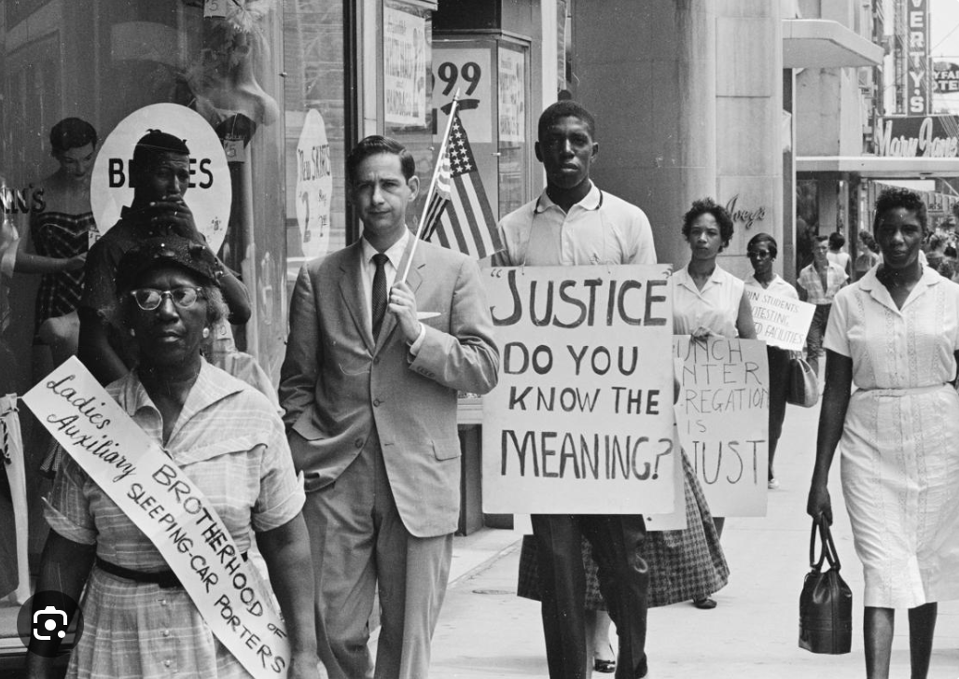
Monday: Gods but the Lord Exodus 20:1–7
Tuesday: One God and One Lord 1 Corinthians 8:1–6
Wednesday:Worship God Alone Matthew 4:1–11
Thursday: The Worship of Worthless Idols Isaiah 44:9–20
Friday: Return to the Lord Isaiah 44:21–28
Saturday: No One Can Serve Two Masters Luke 16:13–17
Sunday: The People Cast Off Restraint Judges 17:1–6

BLACK HISTORY

Association for the Study of African American Life and History
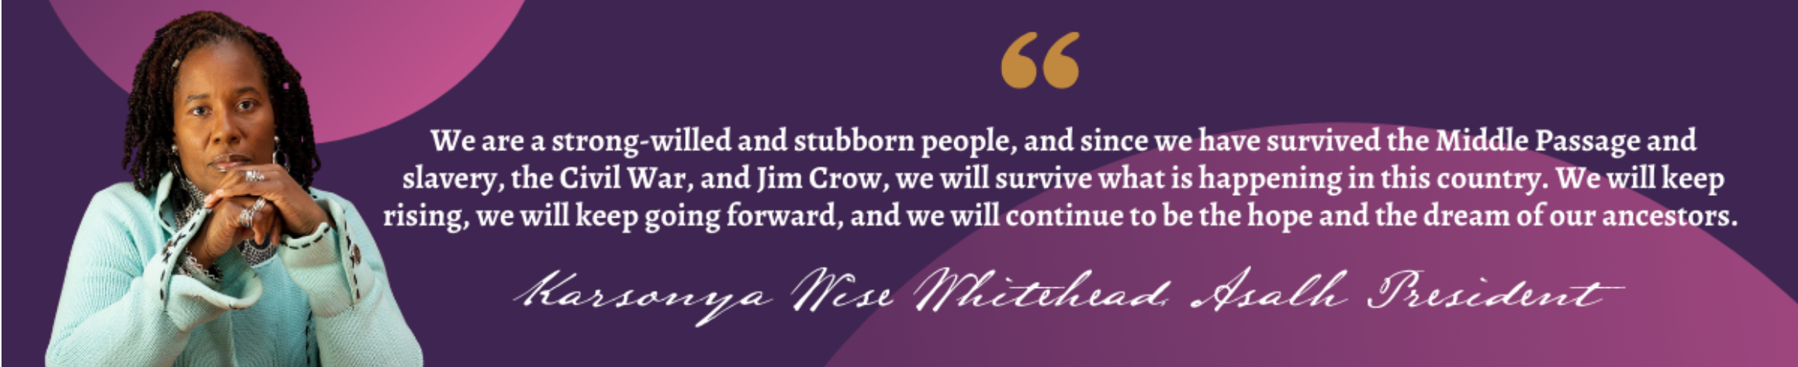

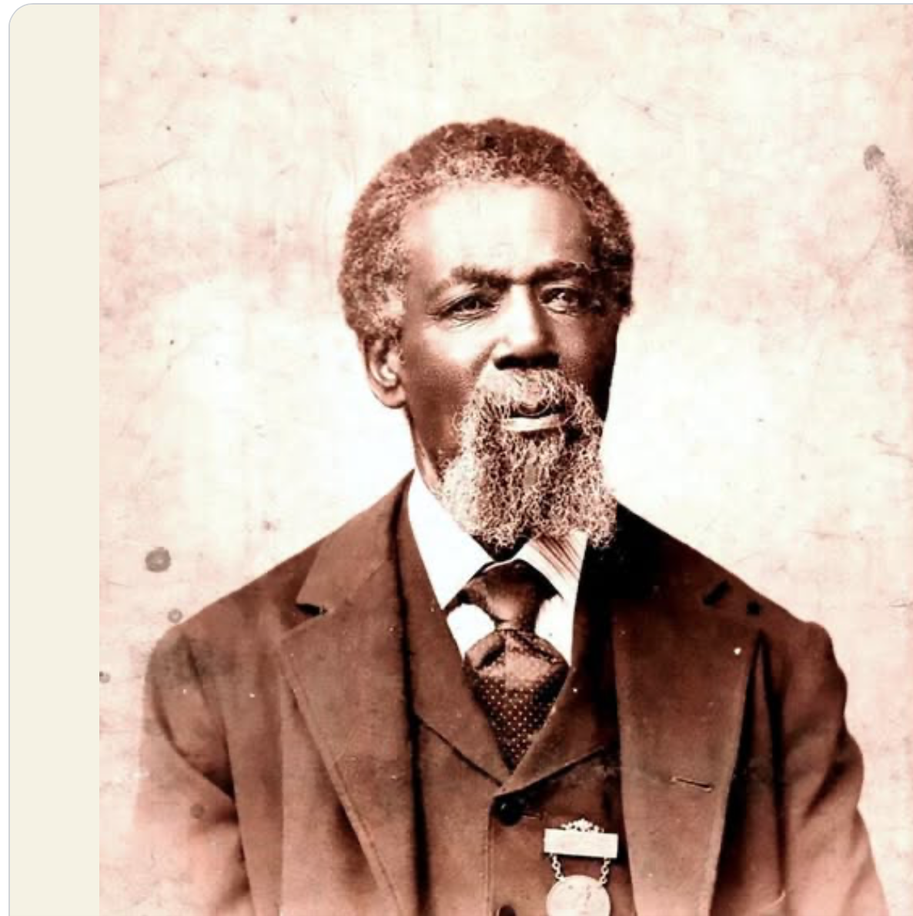
Ask Us About the New ASALH NOVA Branch!!

Thomas Mundy Peterson
Thomas Mundy Peterson (October 6, 1824 – February 4, 1904) of Perth Amboy, New Jersey, has been claimed to be the first African American to vote in an election under the just-enacted provisions of the 15th Amendment to the United States Constitution.

His vote was cast on March 31, 1870; the Amendment had been ratified almost two months earlier, on February 3, but was only officially certified by Secretary of State Hamilton Fish on March 30

Peterson was born in Metuchen, New Jersey. His father, also named Thomas, worked for the Mundy family. His mother, Lucy Green, was a slave of Hugh Newell (1744–1816) of Freehold Township, New Jersey. She was manumitted at age 21 by Newell's will. After moving to Perth Amboy, Peterson married Daphne Reeves, whose mother, Bette, had been a slave on an estate of Andrew Bell in Perth Amboy.^{[3]}

For several years (between 1871 and 1878) Peterson was an employee of the Board of Education, serving as a custodian of School No. 1 located on State Street in Perth Amboy. He was also a general handyman around town and was active in both the United States Republican Party and the Prohibition Party.

It has been claimed that he also holds the distinction of being the city's first "colored" person to serve on a jury, however, no direct evidence has been found.

Peterson is most notably remembered for voting in the local election held at Perth Amboy City Hall over the town's charter. Some citizens wanted to revise the existing charter while others wished to abandon the charter altogether in favor of a township form of government. Peterson cast his ballot in favor of revising the existing charter. This side won 230 to 63.^{[4]} Peterson was afterward appointed to be a member of the committee of seven that made subsequent amendments leading to the final version that was approved by the State Legislature on April 5, 1871.

Historical records as to his contribution to revisions in the form of minutes, writing, or other records are still wanting. Through his work on the committee, he helped shape the city's educational system by aiding in organization of the Perth Amboy Board of Education in 1870 and construction of School No. 1, the city's first public school. When the school opened for classes in 1871, 378 students enrolled and Peterson became its first custodian

Association for the Study of African American Life and History

The mission of the ASALH® is to promote, research, preserve, interpret and disseminate information about Black life, history and culture to the global community. Established on September 9, 1915, by Dr. Carter G. Woodson, we are the Founders of Black History Month and carry forth the work of our founder, the Father of Black History. We continue his legacy of speaking a fundamental truth to the world–that Africans and peoples of African descent are makers of history and co-workers in what W. E. B. Du Bois called, “The Kingdom of Culture.” ASALH is in short, the nexus between the Ivory Tower and the global public.
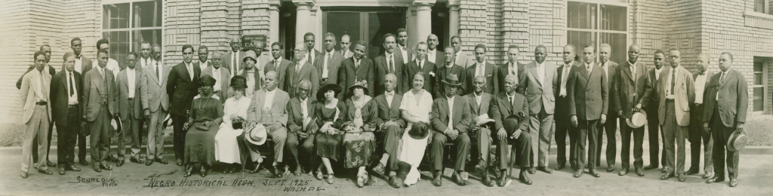
The Negro Historical Association with Carter Woodson (with bow tie) seated next to Mary Church Terrell (in white) in front row, center, of this portrait (1925). Source: Courtesy of the Moorland-Spingarn Research Center, Howard University Archives, Howard University, Washington DC

We are in the final stages of organizing the Northern Virginia Branch. Interested, contact: Deac Joe Boutte, Bro Harvey Woodson, or Rev Gillis M. Taylor.
Join The ASALH NOVA Branch!!

