6 September 2026

Joshua Leads Courageously
Lesson Text: Joshua 1:1-11
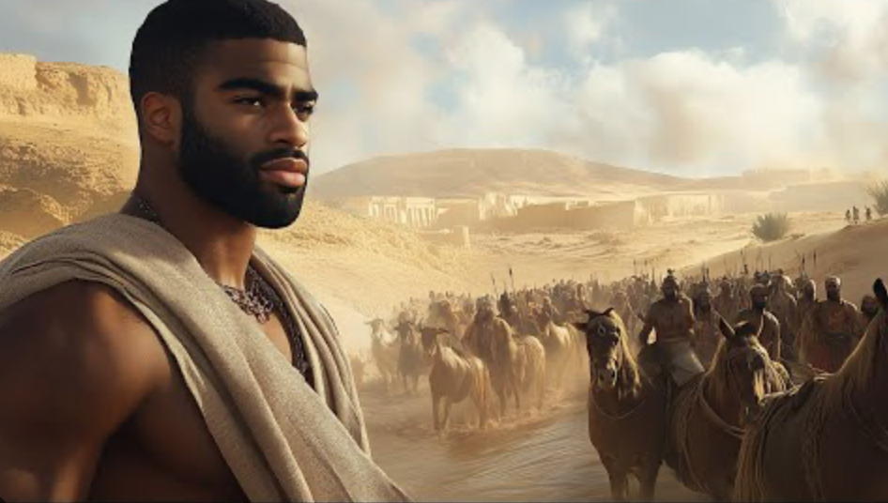
Key Text: “ Have not I commanded thee? Be strong and of a good courage; be not afraid, neither be thou dismayed, for the Lord thy God is with thee whithersoever thou go.”(Joshua 1:9 21st CKJV)
Lesson Aims
After participating in this lesson, we will be able to:
1. Summarize the vision of leadership Joshua received from the Lord.

2. Compare parallels between the Lord’s directives to Joshua and to Moses.

3. Provide a definition of courage and plan to live courageously.

Lesson Text
¹ Now after the death of Moses the servant of the Lord, it came to pass that the Lord spoke unto Joshua the son of Nun, Moses’ minister, saying,
² “Moses My servant is dead. Now therefore arise, go over this Jordan, thou and all this people, unto the land which I give to them, even to the children of Israel.
³ Every place that the sole of your foot shall tread upon, that have I given unto you, as I said unto Moses.
⁴ From the wilderness and this Lebanon even unto the great river, the River Euphrates, all the land of the Hittites, and unto the great sea toward the going down of the sun, shall be your border.
⁵ There shall not any man be able to stand before thee all the days of thy life. As I was with Moses, so I will be with thee: I will not fail thee nor forsake thee.
⁶ Be strong and of a good courage, for unto this people shalt thou divide for an inheritance the land which I swore unto their fathers to give them.
⁷ Only be thou strong and very courageous, that thou mayest observe to do according to all the law, which Moses My servant commanded thee. Turn not from it to the right hand or to the left, that thou mayest prosper whithersoever thou goes.
⁸ This Book of the Law shall not depart out of thy mouth, but thou shalt meditate therein day and night, that thou mayest observe to do according to all that is written therein. For then thou shalt make thy way prosperous and then thou shalt have good success.
⁹ Have not I commanded thee? Be strong and of a good courage; be not afraid, neither be thou dismayed, for the Lord thy God is with thee whithersoever thou go.”
¹⁰ Then Joshua commanded the officers of the people, saying,
¹¹ “Pass through the host and command the people, saying, ‘Prepare you victuals, for within three days ye shall pass over this Jordan to go in to

Introduction
Today’s study introduces us to a group of people who were on the move: the ancient Israelites. They were on the verge of entering the promised land after forty years of wilderness wanderings. Would Joshua, their leader, express uncertainty about the Lord’s provision? Or would his courage strengthen the people as they moved?

Lesson Context
The Israelites lived in Egypt for 430 years (Exodus 12:40–41). Over time, Jacob’s descendants became slaves to the Egyptians. God rescued them and made a way for them to leave. After leaving Egypt, they did not go straight to the land God had promised their ancestors. They first stopped at Mount Sinai, where God gave them the law and they built the tabernacle as their place of worship (Exodus 19–27). Still, the Israelites did not obey God and tested him (Numbers 14:22).

Two years after leaving Egypt, the Israelites left Sinai and traveled toward the southern border of Canaan (Numbers 10:11–12). Moses sent twelve spies to explore the land (13:17), and they came back after forty days (13:25). Ten of the spies did not trust God to help them enter Canaan. Only Joshua and Caleb encouraged the people to go in, believing that God would keep his promise (14:6–9).

Because the ten spies did not have faith, God punished the people. They had to spend forty years wandering in the wilderness (Numbers 14:34). Also, only the two faithful spies, Joshua and Caleb, lived to enter Canaan (1:46; 2:32; 14:30). This meant that Moses would not be allowed to enter Canaan (1:46; 2:32; 14:30). God and Moses chose Joshua to lead the Israelites into Canaan (27:15–23; Deuteronomy 3:28; 31:7; 34:9). At this point, they were camped in the plains of Moab at the edge of Canaan, across the Jordan River from Jericho (Numbers 22:1; 33:48–50; 36:13). Their presence in the area frightened local leaders (22:2–3). However, rather than obey the Lord and maintain holiness, some Israelites committed immoral acts and idolatry with the people of the land—an act that had deadly consequences (Numbers 25).

By the time Moses died, hundreds of years passed since God first promised the land to Abraham. The Israelites were at an important turning point. They still had not settled in the land. With Joshua now leading them, they needed to obey God’s commands to finally take possession of the land he had promised.

Exhortation to Joshua
“After Moses, the servant of the LORD, died at age 120 (Deuteronomy 34:7), the LORD spoke to Joshua, son of Nun, who had served as Moses’ aide. Joshua’s name appears more than twenty times in the first five books of the Old Testament, known as the Pentateuch. In ancient Hebrew, his name means “The Lord saves” or “The Lord is salvation.” Joshua is first introduced as a warrior in Exodus 17:8–13. He is also described as the son of Nun, a descendant of Ephraim (Numbers 13:8; 1 Chronicles 7:20, 27).

In the Hebrew text, the word translated as 'aide' is a verb, which emphasizes Joshua’s role in serving his mentor, Moses. Joshua had served Moses since he was young (see Numbers 11:28). This description also appears in Exodus 24:13 and 33:11. The term draws a comparison between Joshua’s service to Moses and Moses’ own role as the servant of the Lord, even though the Hebrew words for 'aide' and 'servant' are different.

The Lord’s message to Joshua marks a new chapter for the Israelites. With Moses gone, Joshua is now chosen to lead and speak for God as the people prepare to enter the land. Long before this, God promised Abram that his descendants would receive the land of Canaan (Genesis 12:7; 15:8–13; 17:8), and He repeated this promise to Abram’s son and grandson (26:3; 35:12). Moses also received this promise when God called him to lead the Israelites to “a land flowing with milk and honey” (Exodus 3:8; see also Leviticus 20:24; Numbers 13:27; Deuteronomy 31:20). When Moses died, the Israelites still had not settled any land west of the Jordan River. Still, God had already given them the land through His promise to their ancestors.

Crossing the Jordan River would have been easy at the end of the dry season, when the river is calm. But now it is the end of the spring rains (Joshua 4:19), and the river is flooding because of heavy rain and melting snow (3:15; 4:18). Even with these obstacles, God will make it possible for the people to cross. This miracle will show that Joshua is a true leader and that the people are ready to follow God and claim the land.

Extent of the Land
“I will give you every place where you set your foot, as I promised Moses. The Lord reiterates to Joshua the promises that he made to Moses regarding the land in Deuteronomy 11:24. The Israelites do not yet possess the land, but to receive such a promise from the Lord is almost the same as holding the title deed to it. Although conflict and battles will occur (Joshua 11:6–23), the victory ultimately belongs to the Lord and his people.

“Your territory will extend from the desert to Lebanon, and from the great river, the Euphrates—all the Hittite country—to the Mediterranean Sea in the west. The description of the extent of the territory aligns with previous statements (see Genesis 15:18–21; Exodus 23:31; Numbers 34:3–12; Deuteronomy 1:7–8; 11:24). The description begins in the southernmost region of the land (the desert) and extends to the northwest, where the mountains of Lebanon are located. To the northeast and east is the Euphrates River. This river lies more than 400 straight-line miles northeast of the Sea of Galilee. The northern area is summarized by the phrase the Hittite country. At the time of Joshua, in approximately the fourteenth century BC, the Hittites are a rising power. They controlled regions of what is now modern-day Turkey. The western boundary of the land is the Mediterranean Sea.

Encouragement to the People
“No one will be able to stand against you all the days of your life. As I was with Moses, so I will be with you; I will never leave you nor forsake you.” When God gives a command, he often adds words of reassurance. The Israelites will not gain the land by their own power. They will receive it only because the Lord gives it to them.

This is not the first time God promised to be with Joshua (see Deuteronomy 31:23). By making sure no one can stand in Joshua’s way, God shows he will keep his promises and acts as a warrior for his people. Joshua has already seen God’s promises in action. Near the end of Moses’ life, the Israelites took sixty cities east of Galilee (Deuteronomy 3:4). They also had no losses in a battle with the Midianites (Numbers 31:49).

Be strong and courageous, because you will lead these people to inherit the land, I swore to their ancestors to give them.” The command to be strong and courageous shows up eleven times in the Old Testament (Deuteronomy 31:6–7, 23; Joshua 1:6–7, 9, 18; 10:25; 1 Chronicles 22:13; 28:20; 2 Chronicles 32:7).

Dictionaries define courage in different ways, but in short, it is “the quality that enables one to meet danger and difficulties with firmness or valor, despite feelings of fear or inadequacy.” Joshua might have felt afraid or unsure as he led the people. His mentor Moses also felt inadequate (Exodus 3:11).

Still, God chose Joshua and gave him an important job to do. The promise God made to their ancestors can be found in Genesis 12:1–3; 15:18; 26:3; 28:13; 35:12.

Command
“Be strong and very courageous.” This command is so important that it is repeated (see commentary on Joshua 1:6, above). It acts as the main instruction for Joshua and the Israelites as they get ready to enter Canaan. If they choose fear over courage, it will show they do not trust God.

“Be careful to obey all the law my servant Moses gave you; do not turn from it to the right or to the left, that you may be successful wherever you go.” Joshua shows courage and finds success by following the law God gave the Israelites. The customs and promises of the people living in the land will be tempting, as they have been before (Numbers 25). Still, Joshua must stay firm and not follow them. He cannot mix different beliefs or try what seems attractive. As he thinks about this, he might remember God’s command in Deuteronomy 28:14 (compare 5:32–33; 17:11, 20). Joshua’s strong leadership depends on his choice to obey God. Before leading the people in battle, he must first lead them spiritually.

As Joshua thinks about this, he might remember God’s command in Deuteronomy 28:14 (compare 5:32–33; 17:11, 20). His courage as a leader comes mainly from his choice to obey God. Before he can lead the people in battle, he must first show them how to follow God.

Meditation and Obedience
“Keep this Book of the Law always on your lips; meditate on it day and night, so that you may be careful to do everything written in it. Then you will be prosperous and successful. Joshua is told to keep the law close so he can reflect on it, follow it, and enjoy the blessings that come from obedience. His success in leading the people into the promised land depends on this (Deuteronomy 29:9)!

Joshua will learn the law by thinking about it day and night. As the new leader, he will face many important choices, and he needs to make sure his decisions follow what God has said. Any time, day or night, is a good time to think about God’s ways and His Word (compare Psalm 119:15, 23, 48, 78, 97, 99, 148). By putting these commands first, Joshua and those he leads will receive blessings (compare 1:1–3).

The words translated as prosperous and successful appear many times in the Old Testament, but this is the only place where both Hebrew words are used together. Here, being prosperous does not just mean financial gain. It refers to the wider idea of flourishing (compare 2 Chronicles 14:7).

Courage and God’s Presence
“Have I not commanded you? Be strong and courageous. Do not be afraid; do not be discouraged, for the LORD your God will be with you wherever you go.” Here, the Lord reassures Joshua with a question meant to remove any doubt about what will happen. God wants the people’s obedience to bring about what he has planned for centuries: giving a specific land to Abraham and his descendants. God himself will make sure this promise is kept.

This is the third time in this chapter that the Lord tells Joshua to be strong and courageous as he takes on leadership. Moses gave Joshua the same encouragement when he made him his successor (Deuteronomy 31:7, 23). Before, Joshua had Moses’s support and guidance, but now things are different. Joshua must lead on his own, trusting in God’s promises for assurance.

Crossing
Joshua gave orders to the officers of the people. By doing this, he showed his trust in God and his readiness to start entering the land. The officers likely included elders and other leaders, as seen in Numbers 11:16 and Deuteronomy 1:13–16; 29:10; 31:28.

Preparing the People
“Go through the camp and tell the people.” When we look at this verse together with the one before it, we see a clear three-part leadership structure for the Israelites: first, the Lord gives direction to Joshua; second, Joshua passes commands to the officers; and third, the officers make sure the people get the right instructions. Today, we might call this a “chain of command.” This setup would remind the army of Israel, which may have included more than 600,000 soldiers (Numbers 26:2, 51), who was in charge.

‘Get your provisions ready. Three days from now you will cross the Jordan here to go in and take possession of the land the LORD your God is giving you for your own.’ At this point, Joshua is receiving his instructions from God while the Israelites are camped on the plains of Moab (Numbers 26:3, 63), which is east of the Jordan River and just north of the Dead Sea. Looking back, we know that gathering food was only a temporary step, since soon they would stop receiving manna and start eating the produce of the new land (Exodus 16:35; Joshua 5:12). Decades earlier, the people had turned back when they reached this point (see Lesson Context), but this time things would be different.

Conclusion
For the young family I mentioned in the Introduction, the parents’ courageous trust made a real difference. I know this firsthand because they are my parents. Thanks to their faith and trust in God, my older sibling and I were able to thrive. While my parents’ situation was quite different from Joshua’s experience with the ancient Israelites, both stories show how powerful it is when people trust that God will provide.

There are two main lessons we can take from these stories. First, God can use anyone to carry out his plans. Second, God promises to provide for us when we follow him. This does not mean we are guaranteed success by the world’s standards. Instead, God offers us lasting spiritual blessings when we follow his will. Joshua was called to show courage and trust. Will you do the same in the role God has given you?

Take Aways

Closing Prayer

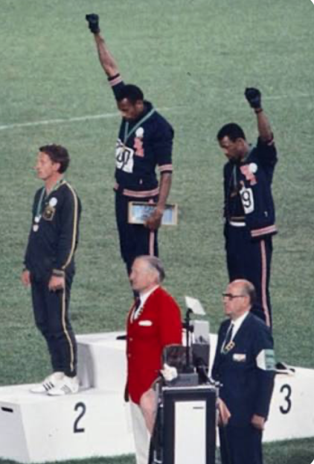

Daily Bible Readings*
(*Liturgical Color: Green (Life, growth, and hope)

Daily Scripture Reading
- Monday: More Than Conquerors Romans 8:31–39
- Tuesday: See What God Has Promised Genesis 13:14–18
- Wednesday: The Promised Land Revealed Deuteronomy 34:1–12
- Thursday: God’s Promised Rest Hebrews 4:1–11
- Friday: God’s New Covenant Hebrews 10:14–18
- Saturday: Whom Shall, I Fear? Psalm 27
- Sunday: Be Strong and Courageous Joshua 1:1–11

BLACK HISTORY

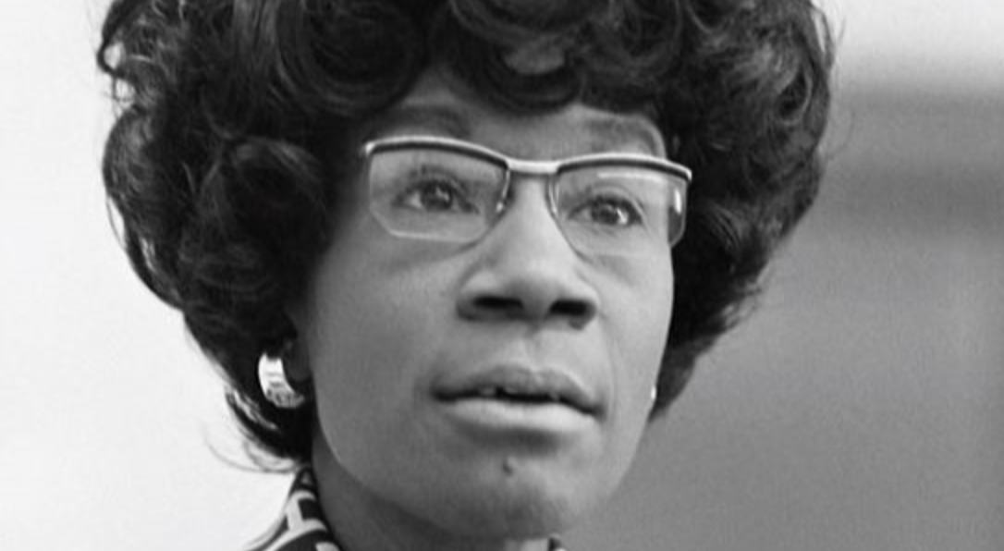
The First African-American Congresswoman Survived Multiple Assassination Attempts When Running for President

Shirley Anita Chisholm, November 30, 1924 – January 1, 2005. In 1968, she became the first Black woman elected to the United States Congress. Chisholm served New York's 12th congressional district, which includes Bedford-Stuyvesant in Brooklyn, for seven terms from 1969 to 1983. In 1972, she was the first Black candidate to seek a major party’s nomination for President of the United States and the first woman to run for the Democratic Party’s presidential nomination. She was known for taking "a resolute stand against economic, social, and political injustices" and for strongly supporting Black civil rights and women's rights.

While campaigning for president, Chisolm made history: she was the first African-American to do so through a major-party nomination. According to The White House, Chisolm had to work harder than most candidates in history just to get her name out. This included suing her way onto televised debates and surviving multiple assassination attempts.
Some today revere Chisolm's efforts, even if they didn't earn her the presidency. According to the BBC, a member of the congressional committee, Kimaya Davis, states, "She paved the way for me to be able to set foot on Capitol Hill."

Although Chisholm did not become the first Black president, she was the first African-American congresswoman.

Association for the Study of African American Life and History

The mission of the ASALH® is to promote, research, preserve, interpret and disseminate information about Black life, history and culture to the global community. Established on September 9, 1915, by Dr. Carter G. Woodson, we are the Founders of Black History Month and carry forth the work of our founder, the Father of Black History. We continue his legacy of speaking a fundamental truth to the world–that Africans and peoples of African descent are makers of history and co-workers in what W. E. B. Du Bois called, “The Kingdom of Culture.” ASALH is in short, the nexus between the Ivory Tower and the global public.
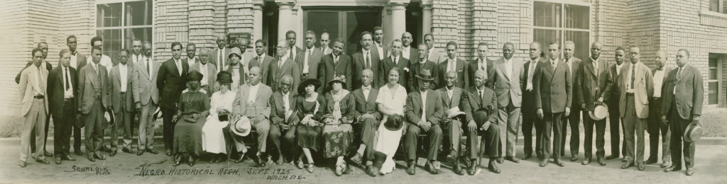
The Negro Historical Association with Carter Woodson (with bow tie) seated next to Mary Church Terrell (in white) in front row, center, of this portrait (1925). Source: Courtesy of the Moorland-Spingarn Research Center, Howard University Archives, Howard University, Washington DC

We are in the final stages of organizing the Northern Virginia Branch. Interested, contact: Deac Joe Boutte, Bro Harvey Woodson, or Rev Gillis M. Taylor.
Join The ASALH NOVA Branch!!

