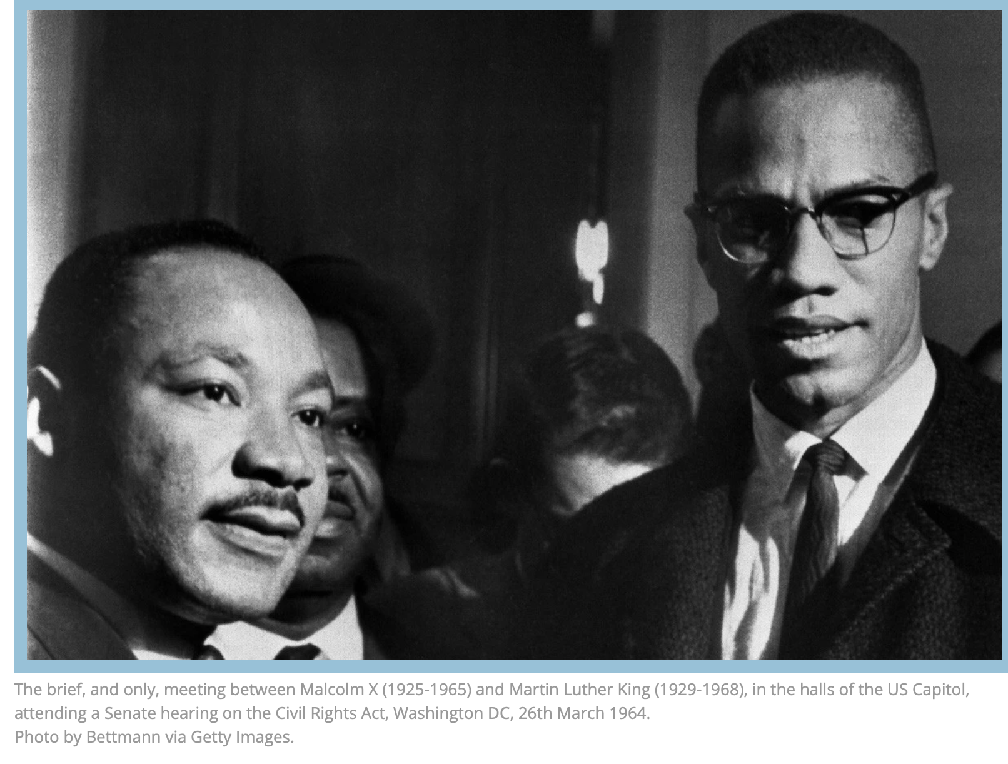
February 23, 2025
John the Baptist Spoke Truth to Power
Speak Truth to Power

Preface
Dr Martin Luther King once said, “America, as I look at you from afar, I wonder whether your moral and spiritual progress has been commensurate with your scientific progress. Your poet Thoreau used to talk about improved means to an unimproved end.⁸ How often this is true. You have allowed the material means by which you live to outdistance the spiritual ends for which you live. You have allowed your mentality to outrun your morality. You have allowed your civilization to outdistance your culture, and through your scientific genius you have made of the world a neighborhood. But through your moral and spiritual genius, you have failed to make of it a brotherhood. And so, America, I would urge you to bring your moral advances in line with your scientific advances.

The misuse of capitalism can also lead to tragic exploitation. This has so often happened in your nation. They tell me that one-tenth of one percent of the population controls more than forty percent of the wealth. Oh, America, how often have you taken necessities from the masses to give luxuries to the classes? If you are to be truly a Christian nation, you must solve this problem. Now, you cannot solve the problem by turning to communism, for communism is based on an ethical relativism and a metaphysical materialism that no Christian can accept. But you can work within the framework of democracy to bring about a better distribution of wealth. You can use your powerful economic resources to wipe poverty from the face of the earth. God never intended for a group of people to live in superfluous, inordinate wealth while others live in abject, deadening poverty. God intends for all His children to have the necessities of life, and He has left in this universe enough and to spare for that purpose. So, I call upon you to bridge the gulf between abject poverty and superfluous wealth. ”

The only thing necessary for the triumph of evil is for good men to do nothing. ~Edmund Burk

John Spoke Truth to Power
Lesson Text- Luke 3:1-14
1Now in the fifteenth year of the reign of Tiberius Caesar, Pontius Pilate being governor of Judea, and Herod being tetrarch of Galilee, and his brother Philip tetrarch of Iturea and of the region of Trachonitis, and Lysanias the tetrarch of Abilene,

2 Annas and Caiaphas being the high priests, the Word of God came unto John the son of Zacharias in the wilderness.

3 And he came into all the country about the Jordan, preaching the baptism of repentance for the remission of sins,

4 as it is written in the book of the words of Isaiah the prophet, saying, “The voice of one crying in the wilderness: ‘Prepare ye the way of the Lord, make His paths straight.

5 Every valley shall be filled, and every mountain and hill shall be brought low; and the crooked shall be made straight, and the rough ways shall be made smooth.

6 and all flesh shall see the salvation of God.’”
7 Then said he to the multitude who came forth to be baptized by him, “O generation of vipers! Who hath warned you to flee from the wrath to come?

8 Bring forth therefore fruits worthy of repentance, and begin not to say among yourselves, ‘We have Abraham as our father.’ For I say unto you, that God is able from these stones to raise up children unto Abraham.

9 And now also the ax is laid unto the root of the trees. Every tree therefore which bringeth not forth good fruit is hewn down and cast into the fire.”

ADDENDUM
10 And the people asked him, saying, “What shall we do then?”

11 He answered and said unto them, “He that hath two coats, let him impart to him that hath none. And he that hath meat, let him do likewise.”

12 Then came also publicans to be baptized, and said unto him, “Master, what shall we do?”

13 And he said unto them, “Exact no more than that which is appointed you.”

14 And the soldiers likewise demanded of him, saying, “And what shall we do?” And he said unto them, “Do violence to no man, neither accuse any falsely; and be content with your wages.”

Historian Clayborne Carson attributes the popularizing of the phrase, Speak Truth to Power, in America to civil rights organizer and peace activist Bayard Rustin, and said that he adapted it in the early 1940s from a saying of Muhammad. Rustin adapted and condensed this concept as part of co-writing the pamphlet Speak Truth to Power: a Quaker Search for an Alternative to Violence which was published in 1955

Introduction
The prophet Isaiah lived about 700 years before the birth of John the Baptist and Jesus Christ. John continued Isaiah’s prophecy pointing toward the arrival of Jesus Christ. John the Baptist proclaimed a message saying, “Prepare the way of the Lord. Make His paths straight. Every valley shall be filled, and every mountain and hill shall be made low and the crooked shall be made straight and rough ways made smooth.”

If we witness someone being mistreated, taken advantage of, or bullied it should anger, frustrate, or cause alarm. Especially, when we feel helpless to do anything about it. Surely, all of us have been on both sides of the spectrum, in some sense or another. When we see a wrong being done, some would say, pray. To others of us, prayer is not enough. Something must be done, or at least something must be said. John the Baptist did and said what was necessary. John was not ambivalent or apathetic in any sense of the words.

John’s crying out was a warning, as well as a prophecy. He warned them to repent of their sins and to be baptized. In his cry from the wilderness, John the Baptist addressed corrupt political, social, government and religious ideology. Primarily his concern was to call for repentance to level the playing field for everyone. There were three groups of people John addressed to ensure the playing field was leveled. They were: 1) the government, 2) the religious leaders and 3) the people.

Foundation Verse
“Every valley shall be exalted, and every mountain and hill shall be made low; and the crooked shall be made straight, and the rough places plain.” (Luke 3:5)
Background
Our first introduction was when Mary and Elizabeth greeted each other and the baby, John, in Elizabeth’s womb leaped. (Luke1:4) We are reintroduced to John in Luke 3:1-14 now an older John the Baptist.

John the Baptist introduced Jesus to the world. This is the confirmation of Isaiah’s prophesy in Isaiah 40:3-5. One commentator said, “The message of John the Baptist pushes further against the division caused by differences in social status.” Those who have must share clothing and food with those who have not; those who cheat and extort must cease. For Luke, the gospel of repentance is not merely a spiritual changing of mind or turning from one’s former ways. It has at its core the obligation and duty to empower all justly.”

John cried out from the wilderness, prepare the way of the Lord. John knew the corrupt practices of the religious council and the Romans, who did not respect Jewish religious traditions. The real reason John was beheaded is because he spoke truth directly to power. John was bound and put in prison because he told Herodias, it was unlawful for him to marry his brother’s wife. “It is not lawful for you to have her.”(Matthew 14:1-12) & (Luke 3:19) Jewish religious council and the Roman government were guilty of abusing God’s people. Are we a voice in the wilderness crying for the disinherited, for the disenfranchised, for justice, for truth, and for equality? Or we apathetic and waiting for the Lord to do the work?

Interpretation and Interrogation of the Text
Luke 3:1-14
1Now in the fifteenth year of the reign of Tiberius Caesar, Pontius Pilate being governor of Judea, and Herod being tetrarch of Galilee, and his brother Philip tetrarch of Iturea and of the region of Trachonitis, and Lysanias the tetrarch of Abilene,
Tiberius Caesar was the Roman emperor during the time of Jesus Christ, Jesus was crucified during Tiberius's reign. Marcus Pontius Pilatus was the governor of Judaea at the time, and he ordered the crucifixion.

Herod the Tetrarch was the title of Herod Antipas, a 1st century ruler of Galilee and Perea: The title "tetrarch" means "ruler of a quarter". It was a Roman title for a ruler of a minor principality, or the fourth part of a province. Herod Antipas was a puppet ruler, appointed by the Roman authorities. He was not as powerful as a king of Israel or a Roman governor, but he did have some influence. He is known for his architectural projects in Jerusalem, including the rebuilding of the Temple, which was destroyed by the Romans in 70 AD.

Philip tetrarch of Iturea (born 20 BCE—died 34 CE) was the son of Herod I the Great and Cleopatra of Jerusalem (not to be confused with another Herod Philip, son of Herod I the Great by Mariamne II). He ruled ably as tetrarch over the former northeastern quarter of his father’s kingdom of Judaea, and of the region of Trachonitis Ituraea a small, mountainous province in the northwest of Palestine, located at the base of Mount Hermon. The area is identified with modern-day southern Syria and parts of northern Jordan.

Lysanias the tetrarch of Abilene Josephus referred to a Lysanias, who in 40 B.C., succeeded his father Ptolemy to the throne of Chalcis; he was put to death by Mark Anthony in 36 B.C. at the instigation of Cleopatra,

These leaders were appointed by the Roman empire to rule over the area. Often their only power was from the ability to call upon Roman forces or those Jews who were aligned with them for support and influence their agenda or abuse of local citizens.

2 Annas and Caiaphas being the high priests, the Word of God came unto John the son of Zacharias in the wilderness. 3 And he came into all the country about the Jordan, preaching the baptism of repentance for the remission of sins,
It is important to note, Annas and Caiaphas were high priest, the word of God was delivered to John the Baptist. This indicates at least two things. First, God choses whom God wills. Second, our earthly positions do not entitle us to be used by God. Bonus: God knew John would deliver the message. God bypassed the connected people and spoke to this oddball character in the wilderness. John did not fit the profile of someone whom God would speak to or through. He wasn’t dressed fashionably or in the appropriate clergical attire, he did not operate in social circles. He was somewhat withdrawn. His thoughts were odd, His dress was odd also. People who hear from God have been considered “odd or out there.” Because they hear different and usually don’t follow the expected social norms. He just didn’t fit the profile. But God spoke to him instead of the socially approved.

The Holy Spirit revealed to John the doctrine of salvation. The revelation came upon him in the desert, where he lived in austerity. This gave him the authority to preach all the objectives of repentance. John lived in the wilderness for most of his life, wearing a camel's hair robe, a leather belt, and eating locusts (grasshoppers) and wild honey. His clothing and lifestyle symbolized his separation from the surrounding culture.

4 as it is written in the book of the words of Isaiah the prophet, saying, “The voice of one crying in the wilderness: ‘Prepare ye the way of the Lord, make His paths straight.
“3 The voice of him that crieth in the wilderness, prepare ye the way of the Lord, make straight in the desert a highway for our God. 4 Every valley shall be exalted, and every mountain and hill shall be made low: and the crooked shall be made straight, and the rough places plain: 5 And the glory of the Lord shall be revealed, and all flesh shall see it together: for the mouth of the Lord hath spoken it.” (Isaiah 40:3-5)

John the Baptist was the voice who proclaimed the coming Messiah. The Messiah, Jesus, proclaimed all the things John spoke of. He and Jesus were two sides of the same coin. Both spoke about spiritual, social and political issues. John, being the forerunner of his cousin, informed the House of Israel about was to happen and Jesus being John’s cousin, did exactly what John said he would do.

To prepare is to make (someone or something) ready for an activity, purpose, to make ourselves ready for something we will do, something we expect to happen; to make or create (something) so it is ready for use. There is work in preparation; sometimes, we do not take into consideration everything is necessary for preparation.

In this preparation, we must consider Micah 6:8, “He hath shown thee, O man, what is good: and what doth the Lord require of thee but to do justly and to love mercy, and to walk humbly with thy God?”(NKJV)

“To do justice,” to do what is fair what is righteous. Justice must be given according to the offense, not according to the offender. Too many times, we have observed justice operating on a racial platform instead of “Considered guilty until proven innocent.”

“To love mercy,” Mercy is an expression of love. To love mercy, is to be generous with forgiving and providing second chances. Especially after a person has paid their debt to society. Returning citizens are hardly given an opportunity to make a decent living. Why is this? Because we have issues with forgiving. This may go doubly when it comes to people of color.

“To walk humbly with God,” is an exercise of unselfishness and piety. Social status does not make one more valuable than another in the eyes of God. The ability and mindset to treat every human being with the same deference; respect the prince and pauper the same.

John observed how the Roman government oppressed Jewish people. He observed the religious council was harsh in applying the law of Moses to their community. We see a two-fold transgression against God’s people, the Roman government and the Jewish religious leaders. Same as today, except we can add racial and ethnic overtones.

Fortunately, we have had, and do have honorable religious leaders, who like John the Baptist speak truth to power, Rev Martin Luther King Jr, Honorable Malcom X, Rev Dr William Barber II, Rev Howard John Wesley, Rev Dietrich Bonhoeffer and Deacon Medgar Evers. They spoke truth to power for everyone regardless of their race, color or creed. Lately we must also include sexual orientation. Because as Dr King said, “Discrimination anywhere is discrimination everywhere.” We may not agree, we must respect another’s humanity.

5 Every valley shall be filled, and every mountain and hill shall be brought low; and the crooked shall be made straight, and the rough ways shall be made smooth; 6 and all flesh shall see the salvation of God.’”
The Kairos- a time when conditions are right for the accomplishment of a crucial action: the opportune and decisive moment. Had arrived. John saw mighty events. This was it; a sharp radical change was about to take place. There was an expectancy, a natural paradigm shift. John saw it Every valley will exalted. Let the low swamps of prejudice and racial pettiness be lifted. Let the cliffs of haughtiness and pride be leveled. Every mountain shall be brought low. We cannot bring to pass the things God will happen, all we can do is open our hearts and allow God to use us to bring about His will.

Every valley shall be filled. A valley has two high points and one low point in the middle. Metaphorically speaking, the low point is an inconsistency, in our government, in our community, in our lives, in our hearts and in our minds. What are the low places we must reconcile with God? Every mountain and hill shall be made low; the mountains could indicate the lofty minded, arrogant individuals, officials and religious leaders. Or they could be obstacles which will be removed from our lives which hinder our relationship with God. Those who are arrogant and conceited will be humbled and those who are subdued shall be lifted. This action can imply justice and equality. We are all the same in the eyes of the Lord. In God, we are equal, given the same opportunity to stand, to kneel and repent before God.

John the Baptist proclaimed the crooked shall be made straight. What was crooked? The government’s transactions were crooked, and the religious council placed heavy burdens on the Jews. What shall be made straight? The actions of the corrupt political, religious and social leaders, who assessed heavy and unfair religious and economic burdens upon their citizens, would be made straight. They levied heavy interest and gouged prices to purchase animals for sacrifices. The business of the temple was crooked, denying those who could not afford the price of a sacrifice and opportunity to participate in the service.(Matthew 21:12-13,Mark 11:15-18) Today, we call them tithes, offerings, assessments and a denial a of living wage.

The rough ways made smooth. The rough places are our lives, whether they are within our hearts or outside of them. The Romans and Jewish religious leaders mistreated the Jews. Religious leaders pronounced hardhearted demands using the law to justify their conduct. Their ways were harsh and rough on the spirit, the heart, and the existence of the people. Rough in all their transaction, scales were unfairly balanced in favor of the merchants and religious leaders. “Dishonest scales are an abomination to the Lord, but a just weight is His delight.” (Proverbs 11:1).

All flesh will see the salvation of God. Salvation equals justice, liberation, perseverance and deliverance. The Jews wanted liberation from the oppressive Roman Empire. They needed liberation from the religious council. They wanted salvation from the oppressive treatment of a government, an end to injustice at the hands of the occupiers, liberation from the burden of Roman taxation in the land they called their own, deliverance from the evils brought to their land by their oppressors. Deliverance from the shame, pain and humiliation the Romans inflicted upon their families.

7 Then said he to the multitude who came forth to be baptized by him, “O generation of vipers! Who hath warned you to flee from the wrath to come?
John said to the crowds that came out to be baptized by him, "You brood of vipers! Who warned you to flee from the wrath to come? John called them a brood of vipers. There were religious leaders in the crowd; they were there to investigate. Vipers are a specific type of snake. Vipers are poisonous, low crawling, cunning creatures, and are only loyal to themselves. John addressed a significant group of people. Consider, he would not call ordinary Jews, vipers. Ordinary Jews were basically powerless.

8 Bring forth therefore fruits worthy of repentance, and begin not to say among yourselves, ‘We have Abraham as our father.’ For I say unto you, that God is able from these stones to raise up children unto Abraham.
John tells them to bear fruits worthy of repentance. Fruits worthy of repentance demonstrate a change of character, a change of heart, a change in our interactions with people. How we treat people is a direct reflection of our relationship with God.

John tells them not begin to say to yourselves, "We have Abraham as our ancestor.” Basically, he was saying, do not use your status as an entitlement. We have a covenant. But a covenant cuts both ways. It is for the giver as well as the receiver. The idea that we hide behind our covenant with God because we have received an inheritance from our forefather is insufficient. We have a responsibility to God and man.

“I tell you; God is able from these stones to raise up children to Abraham.”(Matthew 3:9) Jesus said something similar to this, “Jesus replied to the Pharisees if these were silent, the stones would shout out” (Luke 19:40) This is a symbolic way of saying, the truth about Jesus is so powerful and so compelling cannot be silenced or suppressed. (Luke 23:39-43) The stones knew Jesus. The criminals, the indignant the marginalized, the hated. John is telling them, don’t think because we are of the covenant, we are secure with God.

This also applies to modern day believers; we are God’s children through Jesus Christ. We are still held accountable for what we do (commission) and what we don’t do (omission). If God gives us a truth to speak to power and us, don’t we are not being obedient to God. Most of all, God may depend on speaking what has given us to say to liberate those who may have been in a similar bondage.

9 And even now the ax is laid to the root of the trees. Therefore, every tree which does not bear good fruit is cut down and thrown into the fire.”
John warned them that the ax is lying at the root of the trees; every tree therefore that does not bear good fruit is cut down and thrown into the fire." Who are the trees? They were the powerful leaders of the country, community, and neighborhood, the Pharisees, Sadducees and Scribes, the Sanhedrin, the Roman Empire, and our government.

ADDENDUM
10 And the people asked him, saying, “What shall we do then?”

11 He answered and said unto them, “He that hath two coats, let him impart to him that hath none. And he that hath meat, let him do likewise.”

12 Then came also publicans to be baptized, and said unto him, “Master, what shall we do?”

13 And he said unto them, “Exact no more than that which is appointed you.”

14 And the soldiers likewise demanded of him, saying, “And what shall we do?” And he said unto them, “Do violence to no man, neither accuse any falsely; and be content with your wages.”

Conclusion
John the Baptist did at least two important things. First, John spoke truth to power in a multitude of ways.(Mark 6:18-28) Second, John the Baptist told the Sanhedrin, Pharisees, Sadducees and Scribes what was about to happen. Jesus would make the crooked paths straight, filled every valley, lowered every mountain, and the rough ways smooth; and all the flesh did see the salvation of the Lord. Jesus was the ax that cut down the trees called the Roman Empire, the Sanhedrin, the Pharisees, the Sadducees and the Scribes. But most of all he gave us the template to change things. John and Jesus both demonstrated how to speak truth to power and the consequences to follow.

John pushes further against the divisions caused by differences in social status. Those who have must share clothing and food with those who do not; those who have must cease cheating and extorting. John’s gospel is not merely for repentance or spiritual changing of mind or turning away from our former ways. At its core, John obligates us to empower all to work towards the marginalized and less fortunate.

John and Jesus confronted the powers by placing a mirror before them. They made corrupt powers see the results of their own actions. John was an agitator; he spoke in no uncertain terms. Jesus was a social radical, not a pacifist who got beat up, thrown on a cross which some would make him out to be. His journey to the cross was a call for action. John and Jesus demonstrated what dedication to a cause, or an ideology may cost. In all his speaking John knew and understood, he was paving the way for Jesus, and he must decrease, and Jesus must increase. Rev Vernon Johns, was a type of John the Baptist to Martin Luther King Jr.,, Both are the epitome of the scripture “Greater love has no one than this, than to lay down one’s life for his friends.” (John 15:13 NKJV)

Take Aways
- John was an example of all the aspects of speaking truth to power

- Speaking truth to power is necessary to protect those who do not have a voice.

- Our voices have power; God has blessed each of us with the ability to speak out for justice.

- We may be called upon to be that voice in the wilderness.

Closing Prayer

Paul's Letter to America, Sermon, Martin Luther King, Jr, June 3, 1958, Pittsburgh, Pa.
The most excellent jihad is when one speaks a true word in the presence of a tyrannical ruler", from the Mishkat al-Masabih.
Brian K. Blount, Cain Hope Felder, Clarice J. Martin, Emerson B. Powery, True to Native Land, Minneapolis, MN, Fortress Press, 2007, Page 163
Medgar Evers Mississippi Marty, Michael Vinson Williams, University of Arkansas Press, November 1, 2011
Rev Vernon Johns
The Vernon Johns Story
Rev Vernon Johns Speech to Dexter Ave Baptist Church

