14 April 2024
(Week 33)
Mark
Hosanna!
Focal Verses: Mark 11:1-11

Aim for Change
By the end of the lesson, we will: RECOUNT the story of Jesus’ triumphal entry into Jerusalem; REFLECT on the meaning of Jesus’ triumphal entry into Jerusalem; and DEVELOP a prayer in praise of Jesus’ triumphal entry.
In Focus
Aaron was always a star. He was an athlete and a scholar throughout his high school and college years. Aaron was also a top “draft pick for a leading national football league team in the first round, and he was excited about his future. He had just signed a major deal with his new team and was primed to be a franchise player. With his mother and fiancée, Regina, in the audience, he accepted his new team jersey as the press took pictures and asked questions. As he left the press conference, fans cheered for him. People were screaming his name; fans were trying to get his attention, maybe even an autograph or a picture with him. Aaron thought, I have really arrived; all my dreams are coming true!”

Athletes, entertainers, political figures, and the like are esteemed by the public for their abilities and achievements. However, only what we do for Christ will last, and only God is worthy of such lavish praise and adulation. In today’s lesson, we will look at Jesus’ triumphant return to Jerusalem as people believed He would set up an earthly kingdom and deliver them from their enemies.”

Keep In Mind
Hosanna! Blessed is He that cometh in the name of the Lord! (Mark 11:9)

Lesson Text
Mark 11:1-11
1 And when they came nigh to Jerusalem, unto Bethphage and Bethany at the Mount of Olives, He sent forth two of His disciples
2 and said unto them, “Go your way into the village opposite you, and as soon as ye have entered into it, ye shall find a colt tied, whereon man never sat. Loose him and bring him.
3 And if any man say unto you, ‘Why do ye this?’ say ye that the Lord hath need of him, and straightway he will send him hither.”
4 And they went their way and found the colt tied outside by the door at a place where two ways met, and they loosed him.
5 And certain of those who stood there said unto them, “What do ye, loosing the colt?”
6 And they said unto them even as Jesus had commanded, and they let them go.
7 And they brought the colt to Jesus and cast their garments on him, and He sat upon him.
8 And many spread their garments upon the way, and others cut down branches off the trees and strewed them upon the way.
9 And those who went before, and those who followed, cried, saying, “Hosanna! Blessed is He that cometh in the name of the Lord!
10 Blessed be the kingdom of our father David, that cometh in the name of the Lord! Hosanna in the highest!”
11 And Jesus entered into Jerusalem and into the temple. And when He had looked round about upon all things, as now the eventide had come, He went out unto Bethany with the twelve.

The People, Places and Times
Passover: According to Jewish tradition, the festival of Passover lasts for seven or eight days and commemorates God sparing Jewish lives while they were in brutal servitude to the Egyptians. The name of the holiday comes from the fact that God “passed over” the houses of the Jews when he was slaying the firstborns in Egypt. In Hebrew, it is known as Pesach (PAY-saak) (meaning “passing over” or “protection”). The significance of Jesus coming into Jerusalem at the time of Passover marks His own coming sacrifice at the Cross as the “Passover Lamb” who would take away the sins of the world in the days to come. “The first day of Passover observes the escape of the Jews from the 10th plague, while the remaining seven days mark their liberation from slavery and exodus from Egypt. The Jewish people hold a feast called the Seder on the first night of Passover.

Mount of Olives: It is located east of Jerusalem and stands between Jerusalem and Bethany. Jesus preached from the Mount of Olives and would retreat alone to it at the end of the day, as was His custom (Luke 22:39). This was also the place where He wept over Jerusalem. Not far off, at the bottom of the Mount of Olives, is the Garden of Gethsemane where Jesus prayed with great anguish in His final hours before His betrayal. The first mention of the Mount of Olives in Scripture was when David escaped there on the run from his son Absalom (2 Samuel 15:30). As David’s descendant and prophesied heir to his throne, it was quite befitting Jesus would spend His final hours as David did. As David wept over the events which occurred with his son, the Lord Jesus, after a triumphant entry into Jerusalem, retreated to the Mount of Olives to weep over the holy city (Luke 19:28–44).

Background
Jesus is near the end of His earthly journey. In the previous passage, Mark 10:32–34, for the third time Jesus warns His disciples of what was to come as they go into Jerusalem. The Lord foretells He will be falsely accused, delivered to the chief priest and scribes, and ultimately condemned to death. Jesus lets His disciples know although He will be beaten, mocked, and killed, He will rise again on the third day.

Even as Jesus tells the disciples of the horrors to come, James and John request to have special positions and sit at Jesus’ right hand and left hand when He comes into His kingdom (Mark 10:34– 45). Jesus chides them by letting them know they do not know what they are really asking for, and anyway, the only one who has the authority to give that placement is God the Father. Around the time of Passover, Jesus continues enroute to Jerusalem with His disciples; He also has a great number of people following Him to Jerusalem. He stops through Jericho and has an encounter with blind Bartimaeus, whom He later healed and who immediately followed Jesus, too. “According to Luke’s account, as Jesus neared the holy city, He knew the people were looking for the kingdom of God to come. Like John and James, in their minds His coming meant immediate political power, restoration, and freedom from Roman rule. Jesus tells them the parable of the 10 talents with a warning. He warns those who do not want Him to rule over them that they would be destroyed in His presence (Luke 19:11–27).

In Depth
1. Preparation Fit for a King (Mark 11:1–6) With His disciples, Jesus set out toward the Holy City of Jerusalem to celebrate Passover. This celebration marks the remembrance of God’s great act of deliverance of His people from Egyptian slavery with His mighty hand. The blood of an unblemished lamb was placed on the doorpost of every Israelite, and the death angel passed over them. The Egyptians endured God’s final plague for Pharaoh’s defiance.

Jesus sent two of His disciples ahead and gave them specific instructions to obtain a colt which was tied up and never ridden. Just as Jesus was without blemish or sin, it was fitting that the animal He rode upon also would be untouched. Jesus told the disciples to untie and bring it to Him. When asked what they were doing, they were to say, “The Lord needs it” (Mark 11:3, NLT). Everything occurred just as Jesus said it would, and the disciples obtained the colt on His behalf. Zechariah prophesied the King would come with great rejoicing, riding on a donkey (Zechariah 9:9). This prophecy was fulfilled; Jesus was able to command attention and to get what He needed because He is Lord.

Those who follow Jesus must humbly submit to His authority. We must pave the way for the coming King with hearts yielded to His Lordship and is expressed through prayer, praise, and worship.”

2. Praise Fit for a King (Mark 11: 7–11) As they brought the colt to Jesus, the disciples placed the cloaks on it as a sign of royalty, and the people began to put their cloaks down on the road. Others cut down palm branches and spread them down on the ground to mark the entrance of the King. Palm branches were used at the Feast of Tabernacles or Festival of Booths. These festivals recognized the time Israeli ancestors, under Joshua’s leadership, dwelt in booths (temporary shelters) formed from the branches of trees; the celebrations commemorated their temporary habitations during the journey through the wilderness. For seven days during the Festival of Booths, there was great celebration and then a time of solemn focus on the Law (Nehemiah 8:12–18).

Palm branches are fruitful and have the ability to flourish in spite of the hottest heat. Yet they can grow tall, and their foliage is able to stay green even in arid places. The Jews use palm branches as tokens of victory and peace, which the coming King would bring to His people. As Jesus entered Jerusalem, a crowd went before Him crying out, “Hosanna,” “which is an exclamation of adoration that means “please save us.

As they cried out to Jesus, they also shouted, “Blessed is he that cometh in the name of the Lord” (Mark 11:9). This phrase was prophesied and sung in Psalm 118:25–26. The psalm depicts praise for a great King who is bringing salvation and who will avenge the enemies of God and His people by bringing great deliverance and restoration of order. We, too, wait for this great day of deliverance from the troubles of this world. Jesus is that King and is worthy of every bit of praise that is due to His name. We will appear in the great congregation in heaven, at His throne with white robes and palm branches, to declare His Kingship, as noted in Scripture (Revelation 7:9–10). Every tribe and every nation will declare, “Salvation to our God which sitteth upon the throne, and unto the Lamb” (Revelation 7:10).

Liberating Lesson
Everyone today is seeking their 15 minutes of fame, and technology has made it possible for anyone who is willing to get noticed. More importantly, our world worships daily at the altar of celebrity through the media. Consequently, voyeurism in our society is born from people coveting praise and adulation. People spend more time swooning over fleshy carnal things than they spend praising the mighty King who gave His life to save ours. There is nothing wrong with fame in the right perspective; there are many people who use their celebrity to bring attention to worthy causes. But we as believers must keep fame and fortune in their rightful places by giving all glory and credit to the One who makes it possible. God rewards those who diligently seek Him, but we must never forget the Giver of the gift.

Application for Activation
Every day is a day of thanksgiving! Therefore, it should be a way of life and not an afterthought for Christians to lavish praise on our worthy King. Since the Lord inhabits the praises of His people, we can have unbroken fellowship with Him by blessing Him at all times and keeping His praises continually in our mouths.

Closing Prayer

Week of 07 April 2024
Daily Bible Readings

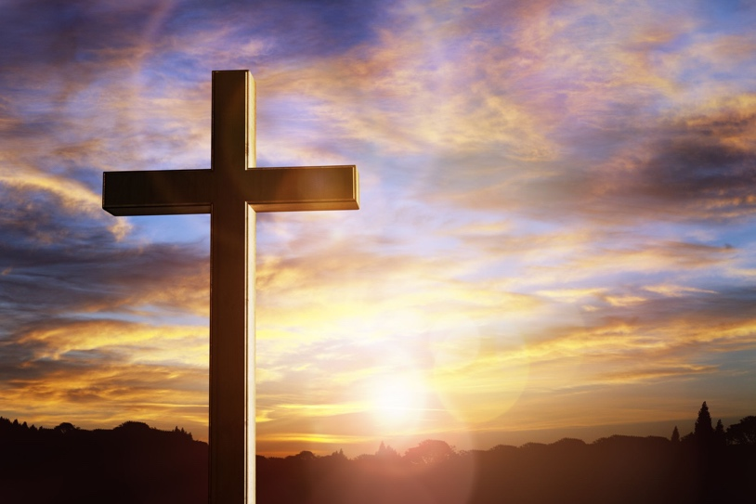

Monday – Jeremiah 4-6
Tuesday – Jeremiah 7-9
Wednesday – Jeremiah 10-13
Thursday – Jeremiah 14-17
Friday – Jeremiah 18-22
Saturday – Jeremiah 23-25
Sunday – Jeremiah 26-29

