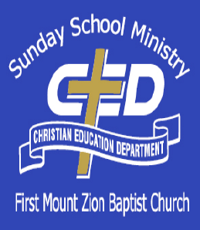
07 January 24
(Week 19)
Ezekiel
God’s Divine Glory Returns
Focal Verses: Ezekiel 43:1-12

Aim for Change
By the end of the lesson, we will: COMPREHEND the vision of God’s holy and merciful glory in the temple; ASSOCIATE a sense of holiness of place with the presence and mercy of God; and GROW in respect for the sacredness of worship settings.
In Focus
Robert had not been to church in a long time. When he bumped into his childhood friend Joyce at the grocery store, he was convicted. She talked about the new pastor and the way certain people were growing in God. He was even jealous that some of the young people whom he had seen in diapers were now actively serving in the church and passionate about the Lord. Despite all his career accomplishments and financial wealth, he knew something was desperately missing in his life. He decided to get back to faithfully attending church starting this Sunday.
He had come to Sunday worship a little early, and no one was around. He saw the empty pews reminded him of what it was like to be in the service worshiping with the people of God. Robert felt overwhelmed just being there in the silence. As he walked down the center aisle, a surge of emotions came over him as he remembered the days when he was passionately following Jesus. Tears began to well up in his eyes. He knew that this was what he was missing.
Although God is everywhere, certain places remind us of His presence and encourage us to live holy lives before Him.
Keep In Mind
“So, the Spirit took me up and brought me into the inner court; and behold, the glory of the Lord filled the house.” (Ezekiel 43:5 KJV)

Lesson Text
Ezekiel 43:1-12
1Afterward he brought me to the gate, even the gate that looked toward the east.
2 And behold, the glory of the God of Israel came from the way of the east; and His voice was like a noise of many waters, and the earth shined with His glory.
3 And it was according to the appearance of the vision which I saw, even according to the vision that I saw when I came to destroy the city. And the visions were like the vision that I saw by the River Chebar; and I fell upon my face.
4 And the glory of the Lord came into the house by the way of the gate whose prospect is toward the east.
5 So the Spirit took me up and brought me into the inner court; and behold, the glory of the Lord filled the house.
6 And I heard Him speaking unto me out of the house; and the man stood by me.
7 And He said unto me, “Son of man, the place of My throne and the place of the soles of My feet, where I will dwell in the midst of the children of Israel for ever, and My holy name, shall the house of Israel no more defile, neither they nor their kings, by their whoredom nor by the carcasses of their kings in their high places.
8 In their setting of their threshold by My thresholds, and their post by My posts, and the wall between Me and them, they have even defiled My holy name by their abominations that they have committed. Therefore I have consumed them in Mine anger.
9 Now let them put away their whoredom and the carcasses of their kings far from Me, and I will dwell in the midst of them for ever.
10 “Thou son of man, show the house to the house of Israel, that they may be ashamed of their iniquities; and let them measure the pattern.
11 And if they be ashamed of all that they have done, show them the form of the house and the fashion thereof, and the goings out thereof and the comings in thereof, and all the forms thereof, and all the ordinances thereof, and all the forms thereof, and all the laws thereof; and write it in their sight, that they may keep the whole form thereof and all the ordinances thereof, and do them.
12 This is the law of the house: Upon the top of the mountain the whole limit thereof round about shall be most holy. Behold, this is the law of the house.

The Lesson
The People, Places and Times
Inner Court: The inner court was a separate area in the temple reserved only for priests. This separate area contained ten golden lampstands. It also contained a table for the shewbread, which was constantly on display and replaced every Sabbath. An altar of incense stood in the inner court before the entrance into the Holy of Holies, where the glory of the Lord was manifested. As a member of the priesthood, Ezekiel was qualified to have access to this area of the temple (1:2).

The River Chebar: The Chebar was a river that ran through the land of the Chaldeans. Many of the captive Jews settled here. Many believe the Chebar was the royal canal of Nebuchadnezzar that joined the Tigris and Euphrates. Ezekiel sat here among the captives and received many of his visions and prophetic words at this location (1:1–3).

Background
During the final section of the book of Ezekiel, there is a special focus on the coming restored temple. These visionary narratives provide a glimpse of God’s plans for His land and His people. Here we can see Ezekiel’s priestly concerns and knowledge come into play. The temple was described in architectural terms in the previous chapters and as such, it is empty and lifeless. Now the glory of God came to the temple. As a result, the temple was full of life. Ezekiel then begins to talk of what that means for those who serve and worship in the temple. Since the glory of God is now present in the temple, its worshipers must be holy. It must not continue to be business as usual. As a priest, Ezekiel stressed the holiness that is required by God and the putting away of all things that would defile the temple.

In Depth
1. The Return of the Glory (Ezekiel 43:1–5) After describing the measurements and the physical description of the temple, Ezekiel is brought to the gate in the east. There he has a vision of the glory of the Lord with both an aural component (the “noise of many waters”) and a visual component (“the earth shined with his glory”). He notices that this vision is similar to the ones in previous chapters where the Lord called him to destroy the city (Ezekiel 9:5–11) and the one that he received at the river Chebar
This is the return of God’s glory to the temple. It is important to note without the glory of God, the temple is just another building. The glory of God animates it and gives it life. Ezekiel recognizes this and falls on his face. The proper response to experiencing the glory of God is authentic worship. Notice Ezekiel didn’t sing a song or begin to preach. He fell on his face because it was God who was there and took center attention.

2. Return to the Glory (vv. 6–9) Next, as Ezekiel is face down in submission to God and His glory, God speaks to him. He lets Ezekiel know the temple must not be defiled by Israel anymore. He refers to Israel’s past actions and the abominations they committed in the temple. They must treat the glory of God with reverence. It is not enough God’s glory has returned to them; they also must return to Him. They must put away their whoredom and the carcasses or memorials of their kings. This word is not just for the common people of Israel but also for her kings and leaders. What God is saying in these verses is that He will not share His glory with anyone else. He will not be worshiped alongside other man-made gods, whether they are statues or men.

God’s glory would return to the temple, but Israel needed to return to Him. Without His glory, they would be just like the temple in the absence of His glory—a lifeless shell. God promises them that if they would return to Him by putting away these abominations, then He would dwell with them forever. This is God’s desire and plan, and this is the true reason the temple is to be rebuilt. God wants to be with His people in a life-giving and sustaining way!

3. The Requirements for the Glory (vv. 10–12) Ezekiel is now commanded to show the temple or “house” to the “house of Israel,” so they would be ashamed of their sins and the things they have done to defile God’s name. Ezekiel is instructed to show them the pattern of the house. The Lord says that if they see the pattern and are ashamed of their sins, then he is to show them all the measurements and architectural designs of the temple. He is to show them the decorations and the ritual acts that are to be performed in the temple. This is what they are to do in order to maintain the presence of God’s glory in the temple.

God also says that there is one major requirement or law from which all other requirements are derived: the law of holiness. The Lord lets Ezekiel know that the temple and the mountain that it sits on are to be holy. This means the people are to be holy in their behavior and actions. Both the place where the Lord’s glory rests and the people who are blessed to have His presence among them are to be holy. Holiness is required to experience the glory of God.

Liberating Lesson
Our society has lost the sense of the sacred. Most people live as if everything is banal and trivial. This type of attitude has even spread to the church. Our worship of God sometimes can be dull and lifeless and treated as something that is man-made and common. God’s presence is always near when His people gather. His glory is meant to be experienced in these settings. The attitude of sacredness and sensitivity to the presence of God ought to permeate our gatherings and continue with us once we go our separate ways. God is a holy God and deserves to be treated as such.

Application for Activation

How can you grow in respect for the sacredness of worship settings? One of the ways you can do this is to begin to pray when you step through the doors of your church. Say a prayer to calm your heart and focus your mind on God. In this way, you can remind yourself of the reason you are there and go in with a desire to experience the glory of God and to worship Him.

Take Aways

Closing Prayer

Week of 01 January 24
Happy New Year!!
Daily Bible Readings

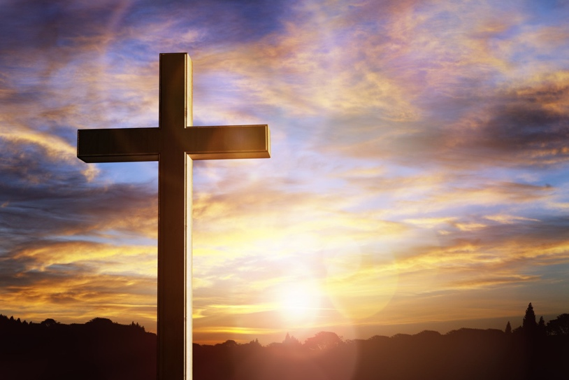

Monday - 1st Chronicles 18-21
Tuesday – 1st Chronicles 22-24
Wednesday -1st Chronicles 25-27
Thursday – 1st/2nd Chronicles 28-1
Friday – 2nd Chronicles 2-5
Saturday – 2nd Chronicles 6-8
Sunday – 2nd Chronicles 9-12

