NOMINATION SUBMISSION 31 May 2023

FMZBC Leadership Nominee for Trustee
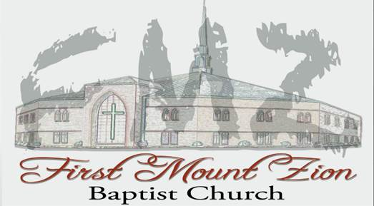
INSERT NOMINEE PIC

TO: Trustee Ministry

Nominees Name: ___________________

Submitted by: _____________________

Zone _________

Criteria

The nominee\candidate must demonstrate qualities found in Acts 6 and 1 Tim 3: 8-13 and I Corinthians 4:2. (No potential nominee is perfect or demonstrates all these qualities)

I nominate _____________________ for consideration as a Trustee Candidate for 2023.
__________________ (nominee’s name) has been a member of First Mount Zion Baptist Church for about _________ years.

Identify ministries or other church activities the nominee currently participates such as Sunday school, Sunday worship service, usher, security, parking lot ministry, bible study and prayer, praise service, etc. Where possible, provide comments regarding the reputation, spiritual maturity, and cooperation and teamwork of the nominee.

Where possible, highlight specify professional experiences, qualifications, educational disciplines possessed by the trustee nominee, such as experience in finance, contract, auditing, human resources and personnel management, project management, facilities management, information technology expertise, and or legal experience/expertise, etc. information that could benefit the church and serving on the Trustee Ministry.

Respectfully submitted,

Submitted by: _______________________________________________
Member First Mount Zion Baptist Church

