NOMINATION SUBMISSION 31 May 2023

FMZBC Leadership Candidate Nominee for Deacon
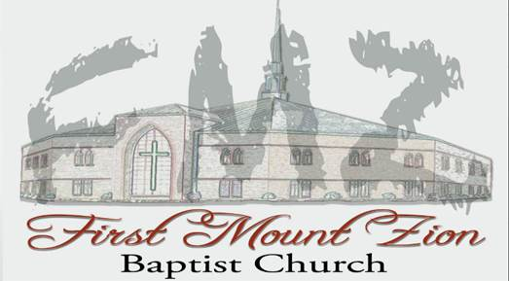
INSERT NOMINEE PIC

TO: Deacon Ministry

Nominees Name: YOUR NOMINEE

Submitted by: Your Name, Zone __

Criteria

The candidate must demonstrate qualities found in Acts 6 & 1 Timothy 3.

Brother is an upstanding Christian who has an outstanding reputation in church and in the community. He is a Christian family person who values family; is married and has two children.

He is a devoted servant who has demonstrated during his years of Small Group Leader, Men’s Choir service his capacity for forbearance and a spirit of appropriate gentleness under pressure. He does not get excited but deals with issues in a calm and gentle manner. is a member of FMZ, attends church with his family on a regular basis, and is very active in his Zone____.

and I have spoken many times concerning tithes and special offerings. He indicated to me that he does support the church by contributing 10% tithes and that in addition he supports special offerings. is a teacher grounded in biblical doctrine, a team player who is open, fair and objective in voicing God’s word. had attended Sunday School, however over the last year and a half as he was in training for Senior Executive Service with the Department of Veterans Administration and while he completed his Master’s Degree.

is a mature Christian and family person. Moreover, he is approachable and would bring over years of leadership experience to the Deacon ministry. I believe that is unencumbered in his affairs lending him to God’s service. By the nature of his civilian and military experience he is knowledgeable of taking care and supporting others and demonstrates great compassion and commitment to members of Zone ___, Hungry for the Word Small Group and employees under his charge at work.
has just completed training and has been promoted to service as a Senior Executive Service within the Department of Veterans Administration. During that time, he continued his service and attendance at church and leading the Small Group for Zone ___. In addition, attained his Master’s Degree. He has established bonds within Zone ___ that strengthened and reinforced the concept of accountability partnerships. Most importantly he is an objective leader who loves God and is willing to unselfishly do His work at First Mount Zion.

Respectfully submitted,

Submitted by
Your name
Member First Mount Zion Baptist Church

