Old Testaments Characters
ACHAN: Sin in the Community
Joshua 7
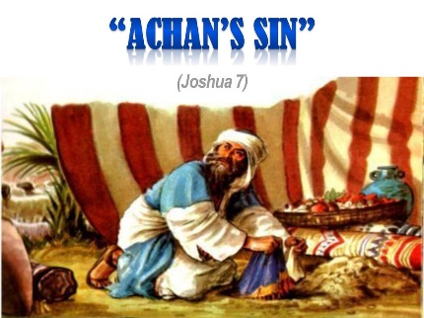
February 23, 2022
Introduction: The effect of individual sin unleashed in the body of Christ can have devasting consequences. It can creep slowly through the life of a church, community and nation quenching the work of the Holy Spirit and hindering the advance of God’s kingdom.
Israel discovered the deadly, far-reaching effect of individual sin during its conquest of Canaan around 1330 B.C. In the midst of a miraculous victory at Jericho (Joshua 6), Achan took several items that were to be devoted to the Lord. Israel experienced the consequences of his sin in the next battle against the smaller city of Ai.
- Retell the story in your own words.
- What happens to Joshua and the Israelites when they attempt to conquer the city of Ai, and why? (vv.1-3)
- After their defeat, verse five says, the heart of the Israelites “melted and became like water.” Imagine that you are a reporter observing the scene. Describe the diverse types of reactions you might hear. Remember they do not yet know the reason for their defeat.
- Describe Joshua’s fears in your own words (vv.6-9)?
- How does God respond to Joshua’s pleas (vv.10-15)
- Why do you think God held all of Israel responsible for the sin of one person?
- What was the root cause of Achan’s sin against God?
- In obedience to God, Israel too radical steps to remedy the situation (vv. 22-26). What guidelines did Jesus give us in Matthew 18:15-17 to maintain holiness in the church?

For Reflection:
When you or someone in your fellowship or church experiences a setback, how do you respond?
What sis or obstacles might be preventing your church or fellowship from progressing according to God’s plan?
What practical steps can you take to build up your fellowship or church this week?

Now or Later: Read Ephesians 4:17-5:7. What type of behavior do you most need to put off and put on?

Prayer and Praise: Joshua 8:1-29 recounts how God granted the Israelites victory over Ai in their second attempt to conquer the city. Ask God to make you a clean vessels through whom he can do mighty works.

On Your own: February is Black History Month. How will you celebrate?
Discover something new you did not know about Black History

Next Study: King Saul: Doing Almost All of God’s Will (1 Samuel 15:1-23)

