FMZBC Connection Points

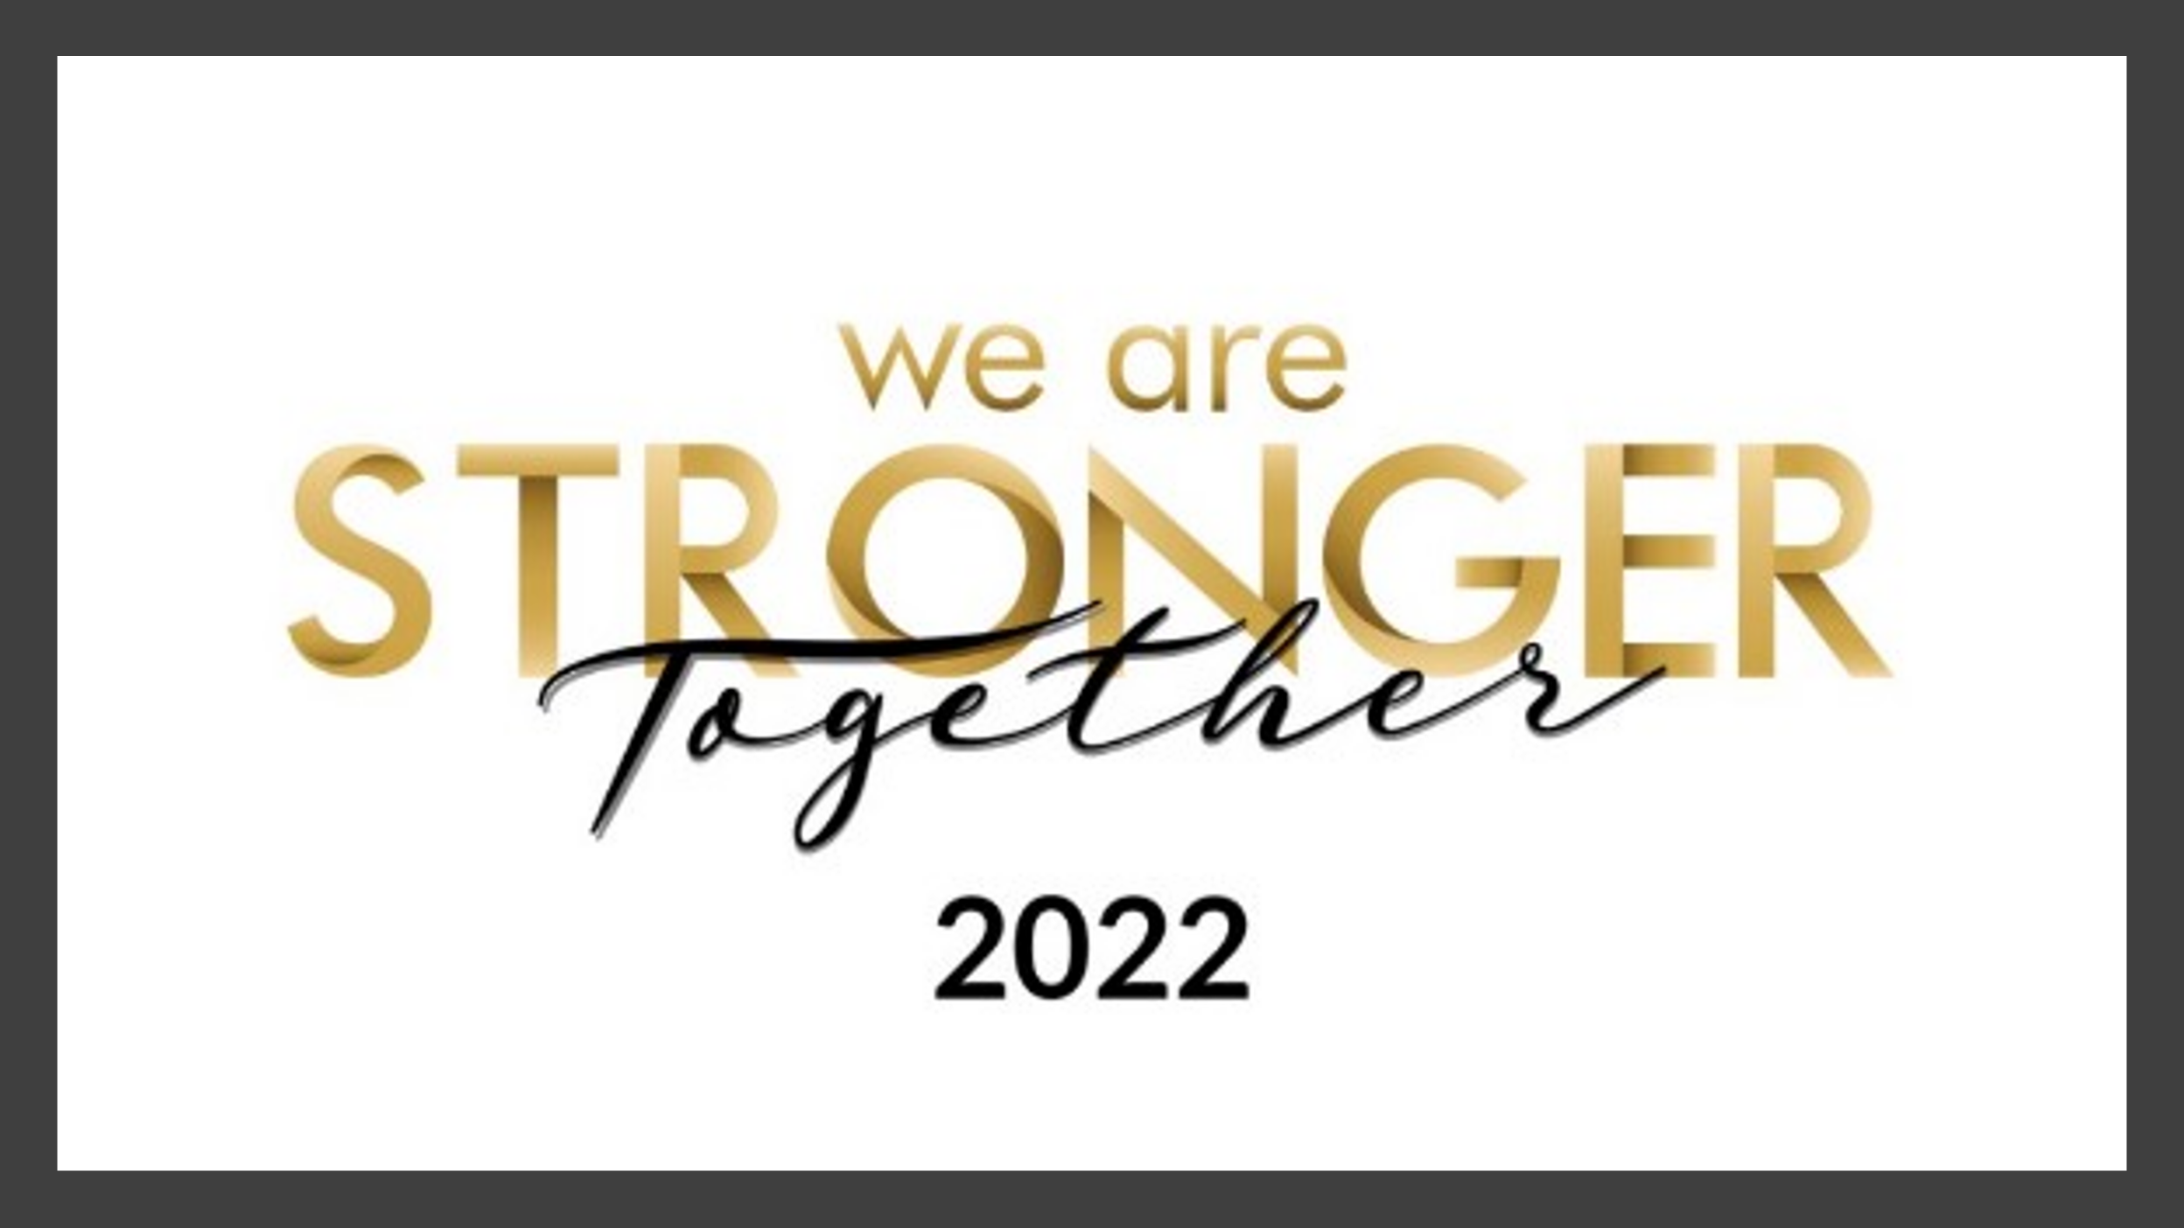

*Let us stay connected* ***January 6, 2022***

***Scroll to the green text for the latest information!***

Join us every Sunday for **Worship** at 11:00 am. **If you are fully vaccinated, please join us in person.** If you are unable to attend in person join us via live stream by going to our website, https://[www.fmzbc.com](http://www.fmzbc.com). You may also join us using any of the following social media platforms.

FMZ/Life Stream:  [https://live.lifestream.tv/first-mount-zion-baptist-church](https://nam12.safelinks.protection.outlook.com/?url=https%3A%2F%2Flive.lifestream.tv%2Ffirst-mount-zion-baptist-church&data=04%7C01%7CRWoolfolk%40FirstMountZionBC.org%7C37750379369b4328c31808d9aaa943a2%7C66d89cb14adc425496b9914ddd4506b0%7C0%7C0%7C637728466240322366%7CUnknown%7CTWFpbGZsb3d8eyJWIjoiMC4wLjAwMDAiLCJQIjoiV2luMzIiLCJBTiI6Ik1haWwiLCJXVCI6Mn0%3D%7C3000&sdata=4e93xSyZeJDrSMzi10rFXIHmHiNEhdrfCso80v1f9DM%3D&reserved=0)

Facebook:  <https://www.facebook.com/fmzbcdumfries>

YouTube:  <https://www.youtube.com/channel/UCzFC03nn-QRn0bzNDEefeGQ>

Bible Study**,** Wednesdays at 7:30 pm. **Bible Study will resume Wednesday, January 12, 2022!**

FMZ/Life Stream:  <https://www.lifestream.tv/fmz-live/>

Facebook:  <https://www.facebook.com/fmzbcdumfries>

YouTube:  <https://www.youtube.com/channel/UCzFC03nn-QRn0bzNDEefeGQ>

Study handouts are available online. <https://firstmountzionbc.org/bible-study-handouts/>

**Sunday School (CED):** Sunday School Extended, every Sunday at 9:45 am on ZOOM

Register in advance for Sunday School Extended:

<https://zoom.us/meeting/register/tJwrfu-upjIsH9VMx4eBFk3D3slWl9YJZAF4>

After registering, you will receive a confirmation email containing information about joining Sunday School Extended. **This information includes the meeting link and dial-in phone number.**

**New Members Orientation Class (CED)**

Zoom Invitation to the New Members’ Orientation Class

Topic: NMOC Classes

Time: Jan 16, 2022, 09:45 AM Eastern Time (US and Canada)

Every week on Sun, until Feb 20, 2022, 7 occurrence(s)

**Jan 16, 2022, 09:45 AM**

Jan 23, 2022, 09:45 AM

Jan 30, 2022, 09:45 AM

Feb 6, 2022, 09:45 AM

Feb 13, 2022, 09:45 AM

Feb 20, 2022, 09:45 AM

Join Zoom Meeting

[**https://us02web.zoom.us/j/89733114170?pwd=QVRTYjYrTWFSbTRBSnhVNk1NTi9UZz09**](https://us02web.zoom.us/j/89733114170?pwd=QVRTYjYrTWFSbTRBSnhVNk1NTi9UZz09)

Meeting ID: 897 3311 4170

Passcode: 700602

Dial by your location

+1 312 626 6799 US (Chicago)

+1 646 558 8656 US (New York)

+1 301 715 8592 US (Washington DC)

Meeting ID: 897 3311 4170

Passcode: 700602

POC: Deborah Holley [fmzbc.nmoc@gmail.com](mailto:fmzbc.nmoc@gmail.com)  
[757-377-5679](tel:(757)%20377-5679)

**SHARE Ministry.** The next SHARE Distribution is **Saturday, January 22, 2022, from 9:00 am-11:00 am.** POC: Thomas Bates,703-330-6371

**Virtual Volunteer Screening: February 19th; April 16th; June 18th; September 17th; October 15th; and November 19, 2022**

POC: Cynthia Zorn Pettigrew at 703 -730-5227, [zornpettigrewcl@comcast.net](mailto:zornpettigrewcl@comcast.net)

or Clarice Torian at 703-730-6353, [toriancj@gmail.com](mailto:toriancj@gmail.com).

**COMMUNION:** Communion elements are available for pick up on a quarterly basis. The next distribution will be in March 2022

**Officer’s Orientation CANCELED. Officer’s installation** will occur during the 11am worship service this **Sunday, January 9, 2022**. Officers may participate in person or virtually.

**Be In The Know. KNOW your member number.**

Member Number. It is important to confirm that you are using the correct member number. One way to verify is to review your online giving account. You may also confirm your member number by calling the office, 703-670-0184.

**Volunteers Needed for Check-In**

**Check-In**

FMZBC requires anyone who enters the Church to go through Check-In, to ensure proof of vaccination is provided; that temperatures are taken, and that masks are worn. As ministry activity increases so does the need for volunteers. If you’d like to volunteer for, Check-In use the following Sign-Up Genius link to serve.

[https://www.signupgenius.com/go/30E0B4CADAB2E5-check](https://nam12.safelinks.protection.outlook.com/?url=https%3A%2F%2Fwww.signupgenius.com%2Fgo%2F30E0B4CADAB2E5-check&data=04%7C01%7CRWoolfolk%40FirstMountZionBC.org%7C65140d79886b4ca6b3e308d99e28a887%7C66d89cb14adc425496b9914ddd4506b0%7C0%7C0%7C637714719741921932%7CUnknown%7CTWFpbGZsb3d8eyJWIjoiMC4wLjAwMDAiLCJQIjoiV2luMzIiLCJBTiI6Ik1haWwiLCJXVCI6Mn0%3D%7C1000&sdata=uk37gaAIDDTmmsTELdaAguNjP9qNdPdbDqBW5aWZ4KU%3D&reserved=0)

If you have any questions, please contact, Renee Woolfolk, Church Business Administrator, at [rwoolfolk@firstmountzionbc.org](mailto:rwoolfolk@firstmountzionbc.org), or call (703) 670-0184.

Thank you to those that have served and continue to serve at Check-In!!

**Kids’ Kingdom (CED):** Kids’ Kingdom, each 3rd Sunday at 11 am on YouTube. Subscribe to FMZBC *Kids’ Kingdom Worship*, YouTube Channel, or click on the Kids’ Kingdom slider on the FMZ website to watch the latest Kids’ Kingdom Worship Service.

**November’s Kids’ Kingdom,** <https://www.youtube.com/watch?v=bUKJziUD6O8>

POC: Dr. Tracey D. Holley, [tholley@firstmountzionbc.org](mailto:tholley@firstmountzionbc.org).

**MEN’S MINISTRY (CED): ATTENTION ALL MEN!!**!…Join our ZOOM Meeting & Fellowship with us on this Saturday, January 8, 2022, at **9:00 AM,**as we discover **"We Are Stronger Together"**.  Our speaker of the day to give the charge will be our very own, **Dr. Luke E. Torian,**esteemed Pastor of the First Mount Zion Baptist Church, who will bring a DYNAMIC message that will fill our spirits and minds!  We pray you seize this opportunity to Glorify GOD thru this online fellowship with your time & service.  We look forward to seeing you Mighty Men of GOD online.

Join the Men’s Ministry on the second Saturday of each month. Check the Sunday announcements for details.

POC, MM Director, Bro. Edward Jones and MM Co-Director, Bro. Stephen Seaberry; [MensMinistry@firstmountzionbc.org](mailto:MensMinistry@firstmountzionbc.org).

**WOMENS’ MINISTRY (CED):**

POC:  Veronica D. Hackett, Director or Gwen L. Holland, Co-Director [womensministry@firstmountzionbc.org](mailto:womensministry@firstmountzionbc.org)

**WOMEN’S MINISTRY (CED): PRAYER REQUESTS,** Women Uniting in Fellowship with Love, Praise, and Worship

Greetings to all our sisters in Christ. God is so awesome! He has answered our prayers and He want to answer yours too! The WM has established a dedicated email for the women of FMZBC to submit your prayer request. We desire to continually lift your prayer needs as they arise, so please use this email to submit your prayer request. Let the saints pray for you. Prayers of the righteous availeth much!  Our Intercessory Prayer Team (IPT) will intercede and faithfully pray over your prayer request as you send them in. [WomensMinistryPrayers@firstmountzionbc.org](mailto:WomensMinistryPrayers@firstmountzionbc.org).

For questions, please contact us via the WM email POC: WM Director, Veronica D. Hackett and WM Co-Director, Gwen L. Holland [womensministry@firstmountzionbc.org](mailto:womensministry@firstmountzionbc.org)

**Youth Ministry** **(CED):** POC: Rev. John C. McNeill, FMZ Youth Minister; [jmcneill@firstmountzionbc.org](mailto:jmcneill@firstmountzionbc.org)

**Music and Arts Ministry:**

POC: Minister Sylstea Sledge, [ssledge@firstmountzionbc.org](mailto:ssledge@firstmountzionbc.org)

**SMALL GROUPS MINISTRY**

Fall 2021-2022 Interest-Based Small Groups

Registration Is Open!

**Register at:**[**https://firstmountzionbc.org/small-group/**](https://firstmountzionbc.org/small-group/)

1. The Fall Semester Small Group Meetings begin October 01, 2021-January 31, 2022.

2. We will continue to use Zoom and or Conference Calls for our group meetings.

3. You do not have to be a member of First Mount Zion Baptist Church to join a Small Group.

3. You must be a First Mount Zion Baptist Church member to lead a Small Group.

We welcome you to join a Small Group! We have a variety of groups from discipleship groups, sports, health and wellness, service, shared interest, support, and book groups for all ages. Regardless of the type of group, the main purpose of each group is to create a place where you can develop and cultivate friendships, receive encouragement and support while lives are being transformed into the image of Christ.  There is a group for everyone, including YOU!! Review our directory of Groups and connect with a Small Group today. 

**Leading a Small Group**

Consider leading a Small Group while utilizing your gifts, passions, and talents.  We’d love to hear from you. Please contact the Small Group Director, share the topic of interest and name of your prospective group, along with the date and time of your online meetings.

You will receive essential tools, an initial Small Group leader training as well as training throughout the year with fellow group leaders. Your group will be placed in the First Mount Zion online Small Groups directory where others can locate your group and register throughout the Fall and Spring semesters. We believe God creatively uses Small Groups while implementing our mission to Make the Connection – Make Disciples – Make a Difference. As a Small Group leader, you are an essential part of that transformation.

**Point of Contact**: Sister Stephanie M. Craddock, Small Groups Director @ [Scraddock@firstmountzionbc.org](mailto:Scraddock@firstmountzionbc.org) or 703-670-0184.

**Weekly Operational Hours**

**Monday - Thursday, 9:00 am - 4:00 pm and Fridays, 9:00 am – 1:00 pm**

Staff office and Fitness Center hours are Monday – Thursday from, 9:00 am - 4:00 pm and Friday from, 9:00 am – 1:00pm. Please **note:** **The Fitness Center is open to members only. The Beauty and Barber Shops are also open during this time by appointment only.**

**Closings and Cancellations Due to Inclement Weather**

During times of inclement weather please check the Church website and voicemail for closings and cancellations. Notices are also posted to WTOP and WJLA. You may also register to receive notifications from, www.cancellations.com

**Change in Check-In Procedures Revised 9/12/21**

For anyone 12 years and older proof of being fully vaccinated is required. Proof of vaccination is only required once. Once proof is shown your name will be entered into a data base. At subsequent check-ins you need only to provide your name. Wearing a mask, having temperature taken, and social distancing are required.

**Am I required to pre-register for Sunday service or to enter the building?** No, providing verification of being fully vaccinated eliminates the need to pre-register.

**What forms of proof of vaccination are accepted?** A legible vaccination card showing your name and date(s) of vaccination; a copy of your card; or a picture on your electronic device are acceptable forms of proof.

**Are children required to show proof of vaccination?** Children 12 years and older are required to show proof of vaccination. Children under the age of 12 are not.

**What if I have a medical condition that prevents me from being vaccinated?** In lieu of a vaccination card, provide medical documentation from a physician stating the medical exemption.

**How do I get my name into the database?** Upon your next arrival to the Church, for any reason, show proof of being fully vaccinated and your name will be added to the database.

Check [www.fmzbc.com](http://www.fmzbc.com) for additional information and updates

Obtaining a copy of your COVID-19 VACCINATION CARD

The Virginia Department of Health now provides copies of vaccination cards. To obtain a copy, go to their Virginia Immunization Information System, <https://vase.vdh.virginia.gov/vacapps/f?p=545:1>

VANCO ONLINE GIVING

VANCO, FMZBC’s on-line giving platform, operates with a high level of security.

As a result, users’ access will be temporarily denied when using a VPN, virtual personal network, and because of too many failed login attempts. If you’ve forgotten your password, after some time the account will reset to allow you to select the forgot password option. Another option is to call the office with your IEP address. The office will then contact VANCO with the IP address to have your VANCO account reset.

**FMZ JOB VACCANCIES**

**Job Vacancies**

FMZBC is seeking to employ the following:

Food Service Assistant Cook-Full-Time

The job announcement and the employment application are available for download.

<https://firstmountzionbc.org/job-vacancy-announcement/>

Please return by email, [employment@firstmountzionbc.org](mailto:employment@firstmountzionbc.org), or return to the office during office hours, Tuesday, and Thursday, 9 am-4 pm. Applications will also be accepted by mail. First Mount Zion Baptist Church, 16622 Dumfries Road, Dumfries, Virginia 22025. Attention: Hiring Manager

**\*\*\*\*\*\*\*\*\*\*\*\*\*\*\*\*\*\*\*\*\*\*\*\*\*\*\*\*\*\*\*\*\*\*\*\*\*\*\*\*\*\*\*\*\*\*\*\*\*\*\*\*\*\*\*\*\*\*\*\*\*\*\*\*\*\*\*\*\*\*\*\*\*\*\*\*\***

**Remain Connected** with us by keeping your contact information current. Please submit a change of contact information online using the following link: <https://form.jotform.com/12155242234>

**IT Help Desk.** Have questions about ZOOM or OFFICE365? Need an Email or password reset? Please email us for assistance at, [IT4U@FirstMountZionBC.Org](mailto:IT4U@FirstMountZionBC.Org) or [rwoolfolk@firstmountzionbc.org](mailto:rwoolfolk@firstmountzionbc.org).

**Giving Tithes and Offerings** (Point of Contact: Ms. Sherry Hilliard, financial secretary, shilliard@firstmountzionbc.org)

* + Online. [WWW.FMZBC.COM](http://www.fmzbc.com/) and click on ONLINE GIVING(VANCO) at any time. To avoid failed transaction fees, please regularly review your online giving account to ensure contact and payment sources are up to date. When submitting a change of address to the Church, please also log on to VANCO to update your address. If you are interested in learning more about VANCO or have any questions as a VANCO online giver, please contact, Ms. Sherry Hilliard by email, [shilliard@firstmountzionbc.org](mailto:shilliard@firstmountzionbc.org), or by phone, (703) 670-0184.
  + Mail. First Mount Zion Baptist Church, 16622 Dumfries Road, Dumfries, Va. 22025.
  + Schedule a time for pick up, from your home, with your Zone Leader.

**ATTENTION ALL ZOOM MEETING HOSTS:** To protect our ministries from potential “Zoom bombing” by miscreants and hackers, it is no longer recommended to post-meeting ID and passcodes to the website or social media. As an alternative, Zoom offers a registration feature for meeting participants to register for a meeting using a registration link. Once the registration link is established by the host, the link can be shared as usual via Connection Points, email, text, etc.  The organizer/host will receive a roster of registrants and, if necessary, can use the list to verify people before they are allowed in the meeting.

* For those who schedule ZOOM meetings, to follow is a short video on how to enable the registration feature to Zoom meetings.
* How to set up a Zoom registration link for better security:  <https://youtu.be/VqomCzNnii4>

**Please check the FMZ website regularly for a complete listing of ministry activities** and updates regarding weather closings during office hours. As always, during these times of uncertainty, safety is of the utmost importance as we do our best to keep the congregation connected and informed while maintaining the health and welfare of all. Please check your email and the Church website for regular updates. Looking forward to our return in the future!

