December 15, 2021
Celebrating the Promise of ADVENT: PEACE (Jesus Is Our Peace) and LOVE (God Is Love)

Introduction: Let Advent be a time that opens your heart for the celebration of our Lord and Savior Jesus Christ. Jesus entered our world as a baby with minimal fanfare, with mountains of hope placed on His shoulders. For centuries, the people of God clung to His promise of a Deliver, and at just the right time, Jesus arrived. We also find ourselves waiting on Jesus, eagerly anticipating His promised return. In this Advent study, I pray you will find encouragement for the wait in your life and trust God’s promises and plan for you. As we prayerfully make this Advent journey together, I pray that we remember and celebrate God’s kindness and trust God’s faithfulness, even when the future seems uncertain. Yes, our HOPE, PEACE, JOY and LOVE has come, and at just the right time, Jesus will be back. Will “you” be ready?

In a word, we need Advent. It calls to mind the longing and anticipation of God’s people as they awaited the promised Messiah and helps us focus on those same sentiments as we await his second coming. Observing Advent is not primarily about what we do or don’t do, it’s about reorienting our hearts around a hope-filled expectation.
In the weeks leading up to Christmas, let me encourage you not to skip over the anticipation to get right to the celebration. Let the expectation simmer. Feel the gravity of the wait, the angst of knowing this world is not as it should be, and the longing for all things to be made right in Christ. Wake up on Christmas morning with Hope, Peace, Joy and Love grown out of a rich season of spiritual preparation. That’s what Advent is all about.
Read: Isaiah 9:6-7,

Jesus Is Our Peace.
A Short Story on Peace: Five months into a war that would last four more years, a remarkable moment of peace occurred. World War I began in July 1914 and the battle only enraged as the holidays approached. Beginning on the evening of December 24, apparently started by German soldiers who adorned their trenches with Christmas trees, a miraculous holiday ceasefire ensued.
History says that the sound of German soldiers singing “Silent Night” was met by the British troops heralding “The First Noel.” Rendering the war-torn space between the trenches hallowed ground, men who had been firing at each other only hours before ventured out to shake hands, exchange Christmas greetings, and share festivities together. Some even reported a game of soccer played amongst the troops on the frozen battlefield.

This momentary truce wasn’t sanctioned by the officers and soldiers were eventually pulled back to their respective posts to resume fighting. Future opportunities to create similar instances were either forbidden or avoided, but this moment would be forever remembered as a beautifully bright light of peace within a very dark storm. With Christ, you can be secure regardless of what's going on around you.
Perhaps you’ve witnessed the handshake before or after a tennis match or the glove tap before heavyweights take their corners. You’ve seen the fist-bumps before the coin toss and even the little leaguers lined up for hi fives post game. There has always been something special about sportsmanship that’s attractive. Opponents who want to crush each other on the sport court sharing side hugs and well wishes on the sidelines.
There is something special about enemies and opponents recognizing the humanity within one another, but even our most peaceful expressions as people can’t compare with the reality of biblical peace afforded by Jesus.
While some, often known as Jewish Zealots, imagined a Messiah who would wield a political sword, overturn the oppressive regime, and orchestrate the return and rise of Israel as a nation, Jesus had other ideas. The Book of Luke records that ideal for us in the best way:
"As He approached and saw the city, He wept over it, saying, 'If you knew this day what would bring peace — but now it is hidden from your eyes. For the days will come on you when your enemies will build an embankment against you, surround you, and hem you in on every side. They will crush you and your children within you to the ground, and they will not leave one stone on another in you, because you did not recognize the time of your visitation.'” Luke 19:41-44

You Can Be Secure: In Luke’s language, the Greek word translated as “peace” doesn’t only mean tranquility between nations or even friendship among individuals. Another part of the definition is such assurance of salvation as to be content with whatever one’s earthly lot. This kind of peace is a “no matter what falls” peace. In one sense, it’s inner peace whether one gets exactly what is hoped for or a rotten outcome altogether. It’s knowing that you aren’t forgotten. It’s remembering that you are loved. It’s understanding that you can be secure regardless of what is going on around you.
Sometimes godly peace will be the beautiful moment of rest between chaotic battles. It will be a temporary ceasefire and a sweet moment of relief from the attack. But then tomorrow comes and there is still an enemy. There is still a struggle. There is still a raging war. His peace, the kind that He left with us, isn’t the absence of fighting but the ability to be full of hope and confident in Christ despite the war (physically and spiritually).
One can rest in times of worldly peace, when the fighting stops, and conflict is resolved. The only way to sleep in heavenly peace, according to Jesus as recorded by Luke, is to recognize who that peace really comes from. When you do, you can rest regardless. If you feel forgotten or attacked, oppressed or overlooked, remember real peace can reign in this life because it’s not from this world.

What Is Peace? ___________________________________________________________________________
Where do you need PEACE in your life? ______________________________________________________
What does it mean for you to have peace? _____________________________________________________
What does Jesus as the “Prince of Peace” mean to you? _________________________________________

Advent, God's Is Love, God’s love expressed, Love for God and Others

Read: John 3:16-17, John 8:12

In the safety and fullness of Christ's love we can love others with action. Great love can be talked about, deep passionate love can be expressed verbally or even written down, but love expressed in action proves that love really exists.
Love moved the heart of our heavenly Father to act on behalf of His children. He sent His only Son, Jesus Christ, to earth to rescue us in great love and by great sacrifice. Great love can be talked about, deep passionate love can be expressed verbally or even written down, but love expressed in action proves that it really exists.
Romans 5:8 says, “But God proves His own love for us in that while we were still sinners, Christ died for us.”
We know God loves us because of the cross. God hasn’t called all of us to lay down our lives as Christ did in His death, but He has called all of us to lay down our lives daily in service and love, which requires a different kind of death—death to our selfish nature.
It’s easy to love our family and friends but loving our enemies or people we don’t know is much harder.
In this Advent season, as you reflect and prepare your heart for the remembrance of Jesus’ coming to earth to rescue us, ask God to put someone on your heart who you can love through an act of kindness.
When Jesus entered our sin-ridden world and gave His life for us, He demonstrated just how much He loves us. In the safety and fullness of His love, we can love others with action.
One of my favorite stories in the Bible is in Luke 7:36-50. In this passage, Jesus was dining at a Pharisee’s home when “a woman in the town who was a sinner” (v. 37) came in and washed Jesus’ feet with her tears and her hair. Then she anointed His feet with perfume. About this brave act of love, Jesus said, “Therefore I tell you, her many sins have been forgiven; that’s why she loved much. But the one who is forgiven little, loves little” (v. 47). The woman expressed her love for Jesus in a vulnerable and extravagant act. She was able to love much because of the love she had received. We can do the same.
Praise God I have been forgiven much! And out of that forgiveness, I can love much. I can express my love for others.
Advent holds significant spiritual meaning for Christians as we reflect on Christ's birth and what it means for our lives, not only at Christmas but year-round
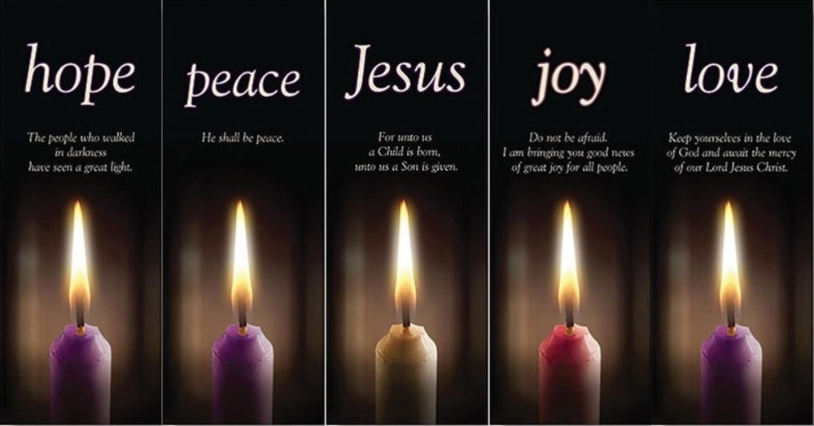

Luke Ch. 15 (The Parables of the Lost Sheep, Lost Coin, and Lost Son)
(NO BIBLE STUDY Dec 22-29 – Next Bible Study January 5, 2022)
Extend joy, hope, peace, love and Jesus to others during the holiday season. I pray that God, the source of hope, will fill you completely with joy and peace because you trust in Him. Then you will overflow with confident hope through the power of the Holy Spirit. — Romans 15:13 NLT

What does real LOVE mean to you? __________________________________________________________
Where do you need the LOVE of God in your life? ______________________________________________
***Have a Merry Christmas and a Happy New Year! ***

